AI-Driven Company-Wide Search Engine
for Deloitte Resources

Final Report

Group Two
ITWS 4100 Capstone
Professor: Richard Plotka
April 27, 2026

Raven Levitt  Project Manager | Felix Tian  System Architect | Matthew Voynovich  Security Researcher
Sophia Turnbow  User Researcher | Jesse Gabriel  Developer | Andrew Jung  Market Researcher

Section 1: Executive Summary
Deloitte employs over 470,000 professionals across more than 150 countries who depend on a vast repository of internal documents, policies, and deliverables. Searching across the firm's fragmented internal platforms is often slow and frustrating, particularly when employees cannot recall the exact title, author, or location of what they need.
To address this, an RPI capstone team of six Information Technology and Computer Science students designed and built a working prototype of an AI-powered search engine. Users issue natural-language queries; the system interprets intent and returns ranked results via a hybrid retrieval pipeline that combines semantic search, keyword matching (BM25), and neural reranking.
The project delivers all four artifacts in Deloitte's brief: requirements grounded in user research, market and security analysis, technical architecture documentation, and a functioning web application. The technology stack (Next.js, FastAPI, PostgreSQL with pgvector and ParadeDB, Qwen3-Embedding-0.6B) is entirely open-source, eliminating the per-user licensing fees that commercial alternatives would impose at Deloitte's scale.
A three-year cost-benefit analysis at a 10% discount rate, assuming 70% adoption among a 50-person pilot and 1.5 hours per week recovered per adopter, yielded a net present value of +$2,168,378, an internal rate of return of approximately 3,700%, and payback within the first month of operation. Total risk exposure was $16,600 in expected monetary value; every scenario tested (worst, base, best) produced a positive NPV.
The team executed on a nine-week Agile schedule with weekly client feedback, demonstrating the prototype against a curated corpus of 80+ sample documents in PDF, DOCX, and PPTX formats.
The result is a proof-of-concept showing what becomes possible when search understands both user intent and the structure of an organization's internal resources. The architecture has a clear path to production: enterprise authentication, multilingual support, expanded corpus ingestion, and evolution from document retrieval to retrieval-augmented answer generation.

Table of Contents

Section 1: Executive Summary 2
Table of Contents 4
Section 2: Introduction 5
Section 3: Client Organization & Description 5
Section 4: Project Team 6
Section 5: Problem Statement 8
Section 6: Strategy & Outline for the Solution (Mini-Strategic Plan) 9
6.1 Industry Definition and Market Size 9
6.2 Five Forces Analysis 9
6.3 Competitive Landscape 10
6.4 Internal Resources and Capabilities 10
6.5 VRIN Analysis 11
6.6 Business-Level Strategy: Focused Differentiation 11
6.7 Build vs. Buy Rationale 12
6.8 Strategic Risks 12
Section 7: Analysis Methodology 13
7.1 Development Methodology 13
7.2 User Research 13
7.3 Market Research 17
7.4 Financial Analysis Approach 18
Section 8: IS/IT Design (Requirements, Code, Screenshots, Database) 19
8.1 System Requirements 19
8.2 Technical Architecture 21
8.3 Search Pipeline Design 22
8.4 Document Ingestion Pipeline 24
8.5 Database Design 25
8.6 Security Architecture 25
8.7 Key Design Decisions 26
8.8 Frontend and User Experience 27
8.9 Deployment Architecture 28
8.10 Working System and Screenshots 29
Section 9: Financial & Cost-Benefit Analysis 29
9.1 Cost Analysis 29
9.2 Benefit Analysis 30
Tangible Benefits 30
Intangible Benefits (Qualitative) 31
9.3 Financial Metrics (ROI, NPV, IRR, Payback) 32
Return on Investment (ROI) 32
Net Present Value (NPV) 32
Internal Rate of Return (IRR) 32
Payback Period 33
9.4 Sensitivity Analysis 34
Break-Even Analysis 34
9.5 Risk Assessment 35
Section 10: Project Management Plan & Schedule 37
10.1 Team Organization and Roles 37
10.2 Development Timeline 37
10.3 Communication and Collaboration Tools 39
10.4 Challenges and Lessons Learned 40
Section 11: Post-Turnover Plan including Education, Training, Maintenance, and Support 41
11.1 Documentation and Knowledge Transfer 41
11.2 Training and Onboarding 41
End User Orientation (Analysts and Managers) 41
Administrator Training (Admin Role) 42
IT Operations Training 42
11.3 Maintenance and Ongoing Support 42
Routine Maintenance (Monthly) 42
Periodic Updates (Quarterly) 42
Support Plan 42
11.4 Recommended Production Roadmap 43
Section 12: Results 43
Section 13: Summary and Conclusions 43
References 44

Section 2: Introduction
Deloitte engaged a team of six students from Rensselaer Polytechnic Institute's ITWS 4100 Information Technology Capstone course to design, develop, and deliver a unified search engine that leverages Natural Language Processing to help employees find relevant files quickly and intuitively. Section 5 details the underlying problem this engagement addresses.
The goal of the project is to create an intelligent search experience that understands user intent, delivers accurate results, and improves productivity across the organization. The project brief specified four deliverables: defined use cases and requirements based on interviews and research, market research on NLP security and boundaries for handling sensitive company data, technical architecture documentation addressing business logic and compliance, and a functioning web application prototype enabling natural language search across provided resources.
This report documents the full scope of the team’s efforts and results over the course of the Spring 2026 semester. It covers the client organization and the problem being addressed, the team’s composition and areas of expertise, the strategic analysis that informed the solution approach, the system’s technical design and implementation, the financial and cost-benefit analysis, the project management plan and timeline, and the results achieved. The report also includes a post-turnover plan for education, training, maintenance, and ongoing support.

Section 3: Client Organization & Description
Deloitte Touche Tohmatsu Limited (Deloitte) is the largest of the Big Four professional services firms by both revenue and headcount, reporting $70.5 billion in aggregate global revenue for fiscal 2025 and employing over 470,000 people across 700+ offices in more than 150 countries (Deloitte Global, 2025).
Deloitte operates across four primary service lines: Audit and Assurance, Consulting, Financial Advisory, and Tax and Legal. The workforce is knowledge-intensive: consultants, auditors, tax advisors, and specialists depend on internal documents, policies, methodologies, past deliverables, and training materials, making the quality of information retrieval a direct driver of workforce productivity and billable utilization.
Deloitte has invested heavily in AI and digital transformation. It launched PairD, an internal generative AI assistant, and committed 36% of its digital budget to AI initiatives. The Deloitte AI Institute and Omnia AI platform represent sustained organizational investment, providing the cultural readiness and technical infrastructure that made this search engine project a natural fit.
The enterprise search market itself is valued at $7.47 billion in 2026 and projected to reach $11.66 billion by 2031 at 9.31% CAGR (Mordor Intelligence, 2026), reflecting industry recognition that intelligent search is now foundational infrastructure. Section 5 quantifies the productivity-loss drivers that make this market relevant at Deloitte's scale.
Throughout the project, the team coordinated with Deloitte stakeholders through the course’s structured engagement process. Feedback sessions were held at key milestones to validate requirements, review prototype progress, and ensure alignment with Deloitte’s expectations for the deliverables.

Section 4: Project Team
The project team consisted of six students at Rensselaer Polytechnic Institute. Roles were assigned to cover the three disciplines this project demands: NLP-powered retrieval systems, AI safety and compliance, and user-centered design research.
Raven Levitt served as Project Manager. Raven is a co-founder of Meridian, a software platform serving thousands of active users, and has managed the full product lifecycle from concept to launch. On this project he owned the schedule, the Jira board, and client-facing communication, and led frontend scaffolding.
Felix Tian served as System Architect. Felix is a senior in Information Technology and Web Science and the lead developer of the FinGPT Search Agent project hosted at Columbia University, which contributed directly applicable hybrid-retrieval and embedding-pipeline experience. He owned the search backend, ingestion pipeline, and overall system architecture.
Sophia Turnbow served as User Researcher. Sophia is a senior dual-majoring in Information Technology and Web Science and Sustainability Studies, with a background in user experience design. She led stakeholder interviews, persona development, wireframe iteration, and the survey-driven design refinements that shaped the final interface.
Matthew Voynovich served as Security Researcher. Matthew is a dual major in Computer Science and Information Technology and Web Science with a concentration in AI, machine learning, and data science. He owned the adversarial-input test corpus, the input-validation layer, and the Section 12 security evaluation of prompt-injection and malformed-document handling.
Jesse Gabriel served as Developer. Jesse is a senior in Computer Science and Information Technology and Web Science with a concentration in Information Security and a Mathematics minor, and holds direct Deloitte internship experience that grounded the product in real consulting workflows. He contributed to ingestion, frontend integration, and project documentation.
Andrew Jung served as Market Researcher. Andrew is a senior in Information Technology and Web Science with an Economics minor, and serves as co-founder and Frontend Lead at TandmAI, an AI governance startup. He led the Five Forces analysis, competitor review, build-versus-buy comparison, and the financial build-up that underlies Section 9.

Section 5: Problem Statement
Deloitte employees rely on a variety of internal sites and platforms to access company documents, policies, slide decks, training materials, and images. These resources are scattered across multiple systems, and searching for a specific item often requires navigating several tools, remembering exact titles or filenames, and knowing which platform a particular resource lives on. When employees cannot clearly describe what they need, or when the resource they are looking for uses different terminology than their query, traditional keyword-based search fails. The result is wasted time, duplicated effort, and frequent reliance on colleagues to locate information manually.
The scale of this problem is well-documented in industry research. According to APQC (2021), knowledge workers spend an average of 2.8 hours per week searching for or requesting information they need to do their jobs, contributing to a 25% loss of the average workweek to productivity drains. A separate study by the Microsoft Work Trend Index (2023) found that 62% of workers report spending too much time searching for information during their workday. Despite this, only 27% of companies have implemented effective search tools to address the issue (Slite, 2025).
The financial impact at Deloitte’s scale is impactful. Professional services billable utilization averaged 68.9% in 2024, below the 70–75% optimal threshold where profitability is maximized (SPI Research, 2025). Every hour a consultant spends searching for a document is an hour that is not billed to a client. With 470,000 employees, even a conservative estimate of the productivity loss represents billions of dollars in unrealized billable capacity annually. Beyond the direct financial cost, the problem creates downstream effects: consultants assemble deliverables from outdated or incorrect document versions, junior employees escalate simple document location requests to senior colleagues, and institutional knowledge remains siloed in individual employees’ memory rather than being discoverable across the organization.
The root cause is not a lack of documents. Deloitte has decades of consulting engagements, audit reports, policy documents, methodologies, and training materials stored across its internal systems. The problem is that this knowledge is not accessible through a single, intelligent interface. Employees are forced to search across multiple platforms using exact keywords, and when those keywords do not match the terminology used in the document, which is a common occurrence in a large, diverse organization, the search returns nothing useful. There is no semantic understanding, no ability to interpret user intent, and no unified retrieval layer that connects all of the organization’s resources.
This is the problem the project addresses: building a search engine that understands natural language, interprets what the user is looking for rather than just matching keywords, and returns relevant results from across the organization’s internal resources, regardless of which platform those resources are stored on or what exact terminology they use.

Section 6: Strategy & Outline for the Solution

6.1 Industry Definition and Market Size
This project is positioned within the enterprise search software industry. Enterprise search platforms are purpose-built systems that index, retrieve, and rank internal organizational content using techniques such as semantic search, keyword search, and neural reranking. The market was valued at $7.47 billion in 2026 and is projected to reach $11.66 billion by 2031, reflecting strong growth in demand for tools that help knowledge workers locate internal information efficiently.
For this analysis, the competitive set excludes general productivity suites with embedded search features, such as Notion AI, Slack AI, and Microsoft 365 Copilot. Those tools provide limited search functionality but are not designed to serve as full enterprise search platforms across heterogeneous repositories, document types, and role-based permission structures. Deloitte's environment requires a purpose-built retrieval system: enterprise search is a dedicated organizational capability, not a feature inside a broader collaboration suite.

6.2 Five Forces Analysis
The enterprise search industry is attractive because demand is durable and tied to persistent organizational inefficiencies. Knowledge workers spend substantial time searching for information, and that inefficiency does not disappear during economic downturns because it is rooted in organizational complexity. At the same time, recent advances in retrieval-augmented generation, embeddings, and generative AI have made search systems more capable and strategically important.
However, the competitive forces in the industry are intense. Threat of new entrants is high because open-source retrieval frameworks, embedding models, and cloud infrastructure have lowered the cost of building functional search systems. Supplier power is low to moderate (cloud and embeddings are commoditized, though specialized rerankers create pockets of dependency). Buyer power is high because large enterprises are sophisticated purchasers and can build internal alternatives. Substitutes are a moderate threat from bundled search tools inside major productivity ecosystems. Rivalry is high, with well-funded firms such as Glean, Elastic, Coveo, and Microsoft continuously improving their products in a fast-cycle market.

6.3 Competitive Landscape
The most relevant competitors in the enterprise search space are Glean, Elastic, Microsoft Search, Coveo, and Algolia. Among these, Glean and Microsoft Search are the most direct alternatives because they target large organizations looking to improve internal knowledge retrieval. Glean is a purpose-built AI enterprise search platform with strong application integrations and personalization capabilities, but it is expensive and introduces vendor lock-in. Microsoft Search benefits from existing Microsoft ecosystem adoption and low marginal cost for current customers, but it is constrained by limited file-type support and dependence on the Microsoft stack.
Elastic offers strong flexibility and customization through an open-source foundation but is better understood as search infrastructure than a finished enterprise product. Coveo is strong in customer-facing and commerce-oriented search but less aligned to Deloitte's internal knowledge retrieval needs. Algolia is fast to implement and developer-friendly but is primarily optimized for conventional search and offers less depth in semantic enterprise retrieval. Overall, while commercial platforms are strong, none fully match the combination of Deloitte-specific content, workflow alignment, access control, and data sovereignty that an internal solution can provide.

6.4 Internal Resources and Capabilities
Deloitte’s internal position strongly supports an internal search initiative. The firm reported $70.5 billion in revenue for FY2025, employs more than 470,000 people, and operates across a globally distributed, knowledge-intensive workforce. This creates both the need for better information retrieval and the organizational capacity to build and support such a system.
From a resource perspective, Deloitte has substantial tangible assets, including financial capacity, enterprise-grade infrastructure, and a massive corpus of internal documents accumulated over decades. It also has critical intangible resources, including professional-services domain expertise, an established innovation culture through the Deloitte AI Institute and Omnia AI, and a reputation that demands strict handling of confidential client and firm information. These resources combine into valuable organizational capabilities: in-house AI and engineering talent, mature data governance practices, and experience deploying applications across a large global organization.
Within Deloitte’s value chain, the search engine functions as both a product and a support capability. Its value-creating activities include document ingestion, embedding generation, hybrid retrieval, reranking, access control filtering, interface delivery, and feedback-based search improvement. Because the system directly improves access to organizational knowledge, it also serves as a management information systems capability that supports Deloitte’s broader consulting, audit, tax, and advisory work.

6.5 VRIN Analysis
The VRIN analysis shows that Deloitte’s sustainable competitive advantage comes primarily from its proprietary internal document corpus, not from the search technology alone. The corpus is valuable because it enables faster and more relevant retrieval of internal knowledge. It is rare because no outside organization has access to Deloitte’s specific body of historical deliverables, policies, methodologies, and training materials. It is costly to imitate because it was created over decades through unique firm activity, and it is nonsubstitutable because no external knowledge base can replace the value of Deloitte’s own institutional content. This makes the corpus a true source of sustainable advantage.
Other resources are important but less defensible. Deloitte's domain expertise in professional-services search provides a temporary advantage, but competing firms could develop similar expertise over time. RBAC and compliance infrastructure is necessary but broadly available across enterprises, making it a source of parity rather than differentiation. The hybrid search pipeline and open-source stack reduce vendor dependence but do not constitute a durable moat, since similar architectures can be replicated. The central strategic insight is that the technology is the delivery mechanism, but the data is the moat.

6.6 Business-Level Strategy: Focused Differentiation
Our recommended business-level strategy for this initiative is focused differentiation. The scope is narrow by design: this is not a product for the general market, but an internal system tailored to the needs of Deloitte’s workforce. Within that narrow scope, the objective is not simply to minimize cost, but to deliver a search experience that is meaningfully superior for Deloitte users because it is tuned to their documents, vocabulary, organizational structure, and security requirements.
This differentiation comes from three sources. First, the search engine can be optimized for professional-services work, including Deloitte-specific document types and search behavior patterns. Second, it can enforce access controls that reflect Deloitte’s internal hierarchy and governance model. Third, it preserves complete data sovereignty by keeping sensitive internal and client-related materials under Deloitte’s control rather than routing them through a third-party platform. Although the open-source stack also produces major cost advantages, those savings are a byproduct of architectural choices rather than the primary strategic objective. The strategic priority is distinctiveness and fit, not generic low-cost leadership.

6.7 Build vs. Buy Rationale
The build-versus-buy decision strongly favors building internally. Commercial enterprise search platforms can provide usable functionality, but at Deloitte’s scale their recurring licensing costs become enormous. For example, a platform priced at approximately $20 per user per month would cost more than $112 million annually across Deloitte’s workforce. By contrast, the team’s architecture is built on an open-source-first stack that avoids per-user licensing fees and reduces long-term vendor dependency.
Just as important, an internal build better matches Deloitte’s strategic needs. A custom system can be tuned for the firm’s own vocabulary, document types, access-control model, and workflow patterns in ways that a commercial platform cannot fully replicate. It also ensures that highly sensitive internal and client-related information never leaves Deloitte-controlled infrastructure. In strategic terms, building the system is a high-commitment action, but one that creates durable internal value through better organizational fit, stronger governance, and greater control over a core information systems capability.

6.8 Strategic Risks
The focused differentiation strategy does carry meaningful risks. One risk is out-focusing, where a more specialized solution for a single service line or use case could outperform a firm-wide search tool within that narrower segment. This risk can be mitigated by designing the architecture to support modular tuning for different service lines without fragmenting into entirely separate systems.
A second risk is that a major platform vendor, especially Microsoft or Google, could improve embedded enterprise search enough that a dedicated internal tool appears less necessary. A third is that Deloitte's information environment could standardize over time, reducing the value of a specialized solution if documents and workflows converge into a single platform with strong native search. These risks do not invalidate the strategy but establish its boundary conditions. Maintaining the advantage requires continued benchmarking against commercial alternatives, evolution of relevance quality, and preservation of the moat created by proprietary data and domain tuning.

Section 7: Analysis Methodology

7.1 Development Methodology
The project followed an Agile development methodology organized around a nine-week timeline aligned with the Spring 2026 semester. The team used Kanban boards and Calendar view in Jira to manage tasks, track progress, and visualize workstream dependencies across development, research, and design efforts. GitHub served as the central version control platform, Google Drive supported document collaboration across all team members, and Discord facilitated daily communication and coordination.
Development progressed through nine sequential phases, each focused on a distinct layer of the system: (1) project infrastructure and Docker Compose orchestration, (2) database schema and index initialization, (3) backend API scaffolding with FastAPI, (4) external embedding service deployment, (5) document ingestion pipeline with Docling, (6) hybrid search pipeline with Reciprocal Rank Fusion, (7) frontend implementation with Next.js, (8) admin upload portal, and (9) integration testing with demo data. This phased approach ensured that foundational infrastructure was stable before higher-level application logic was built on top of it, reducing the risk of cascading failures during integration.
The team coordinated with Deloitte stakeholders through structured weekly meetings to provide progress updates, gather feedback, and validate requirements at each milestone. This regular feedback loop allowed the team to adjust priorities based on client input. For example, following a stakeholder meeting on March 12, 2026, the team deprioritized the admin upload portal in favor of refining the core search experience, based on Deloitte's guidance that documents would be pre-loaded sample data rather than user-uploaded content in the prototype.
AI-assisted development tooling, specifically Claude Code (Anthropic's agentic coding CLI), was used throughout the implementation phases to accelerate development velocity. The system architect used Claude Code for architectural scaffolding, code generation, debugging, and documentation, enabling a small team to deliver a full-stack prototype within the compressed semester timeline. All AI-generated code was reviewed, tested, and validated by team members before integration.

7.2 User Research
User research was conducted in parallel with system design and prototyping to ground interface decisions in real user needs and workflows. Because direct stakeholder interviews and large-scale usability testing were not feasible, the team adopted a hybrid approach: iterative client meetings combined with a structured user survey distributed to client representatives, capturing both qualitative and experience-based insights from people familiar with Deloitte's tools.
The research spanned consulting, tax, and audit service lines to reflect the diversity of search behaviors within the organization. The survey targeted four objectives: how users currently interact with internal search systems, common pain points, the document types most frequently searched for, and presentation preferences for results and metadata.
Responses revealed consistent themes. Users described existing search systems as overwhelming, with large volumes of irrelevant or outdated results and difficulty identifying the correct document even when present. Recency emerged as critical to user trust, with outdated documents reducing confidence. Users also flagged inefficient workflows (multiple browser tabs) and challenges with legacy naming conventions left over from organizational restructuring.
To address these findings, the team began with low-fidelity wireframes in two directions. The first followed a traditional dashboard-style layout with multiple panels for saved items, recent documents, and news (Figure 7.2.1: Homepage Version A), based on the example layout the client shared. The second adopted a minimalist, search-focused interface centered on a single primary interaction (Figure 7.2.2: Homepage Version B).
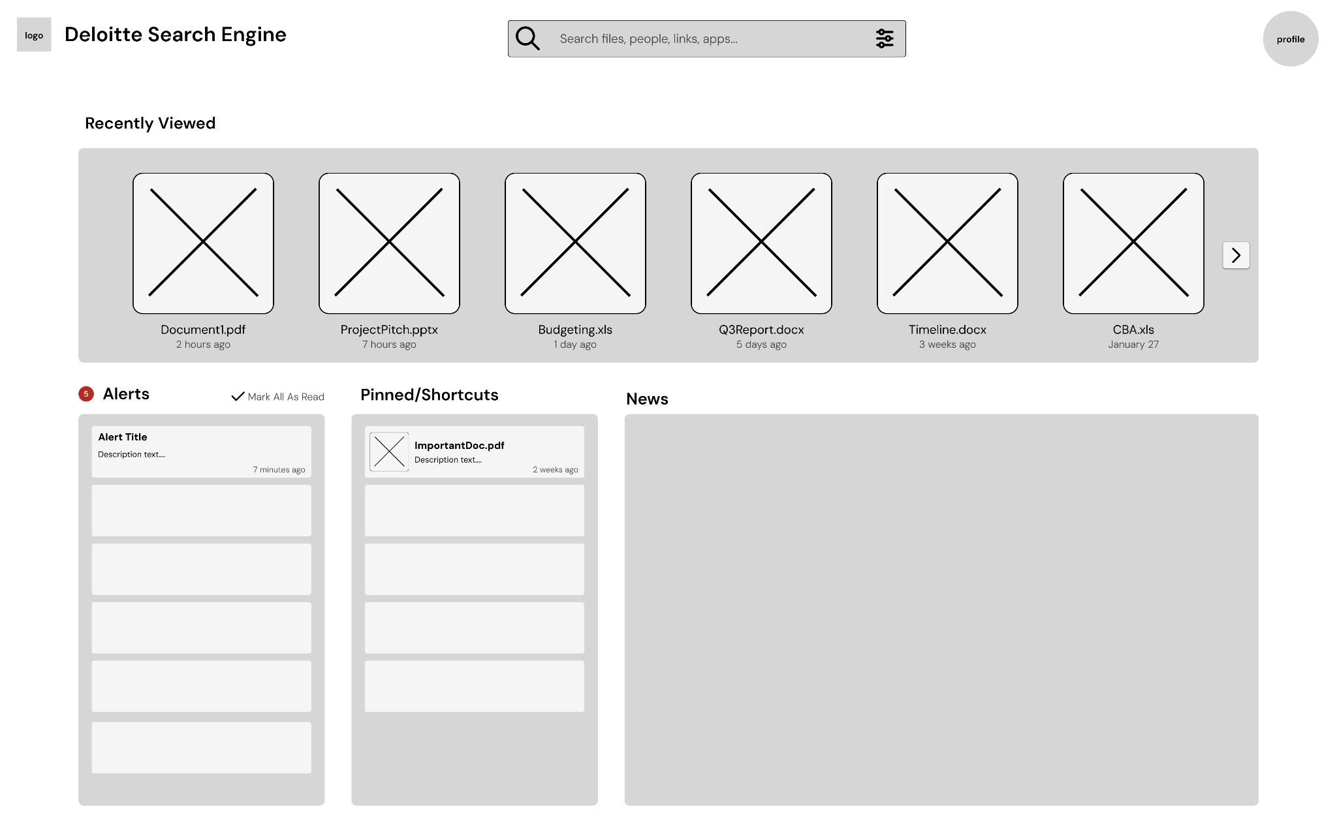
Figure 7.2.1: Wireframe Homepage Version A
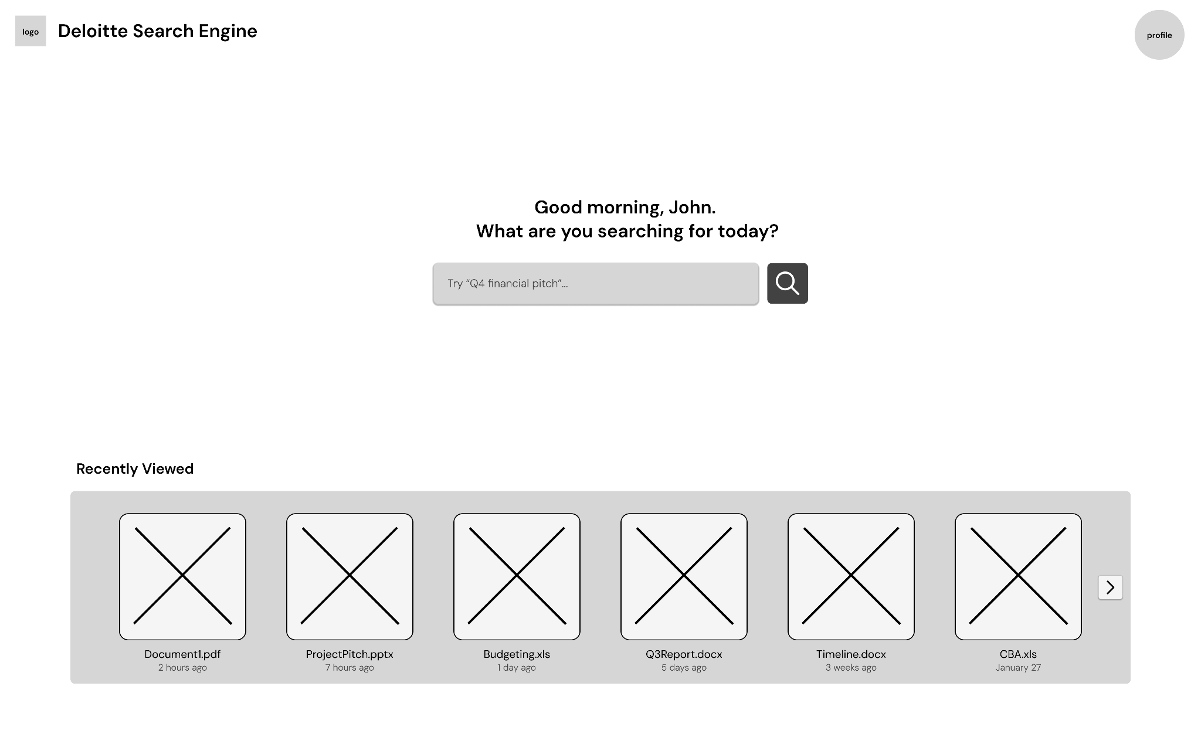
Figure 7.2.2: Wireframe Homepage Version B
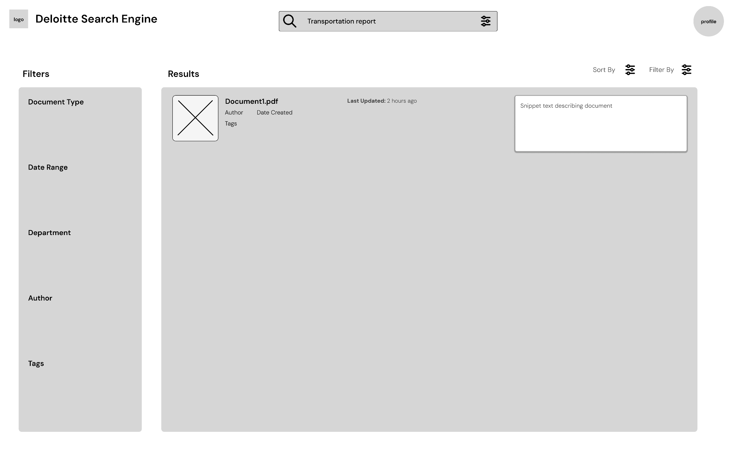
Figure 7.2.3: Wireframe Search Results
The clients strongly favored Version B, the minimalist direction, due to its clarity, reduced cognitive load, and alignment with modern search expectations. Elements from the dashboard direction, specifically recently viewed items and pinned or saved documents, were identified as valuable and folded into the main content flow rather than isolated panels. Two intermediate mockup iterations explored color, hierarchy, and saved-item placement before converging on the final mockups shown in Figures 7.2.4 and 7.2.5.
Further refinement was informed directly by survey responses. The emphasis on recency led to the prioritization of "last updated" metadata in search results, while concerns about irrelevant content drove the introduction of visual hierarchy techniques such as highlighting the most relevant result (Figure 7.2.5). Feedback on visual clutter guided the reduction of color and the adoption of a cleaner, more restrained interface.
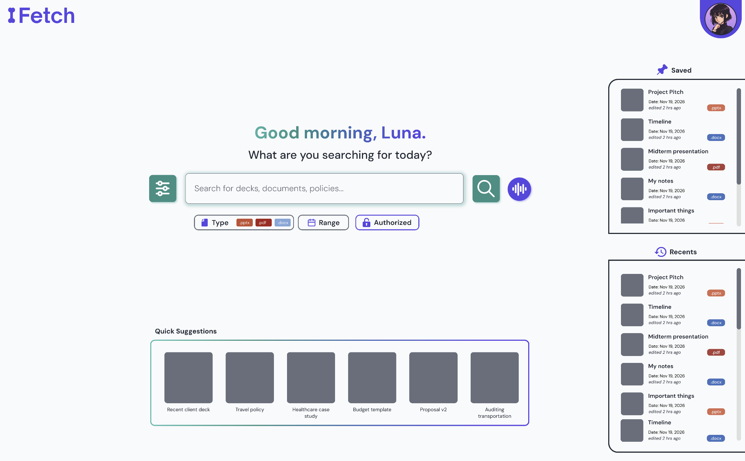
Figure 7.2.4: Homepage Mockup FINAL
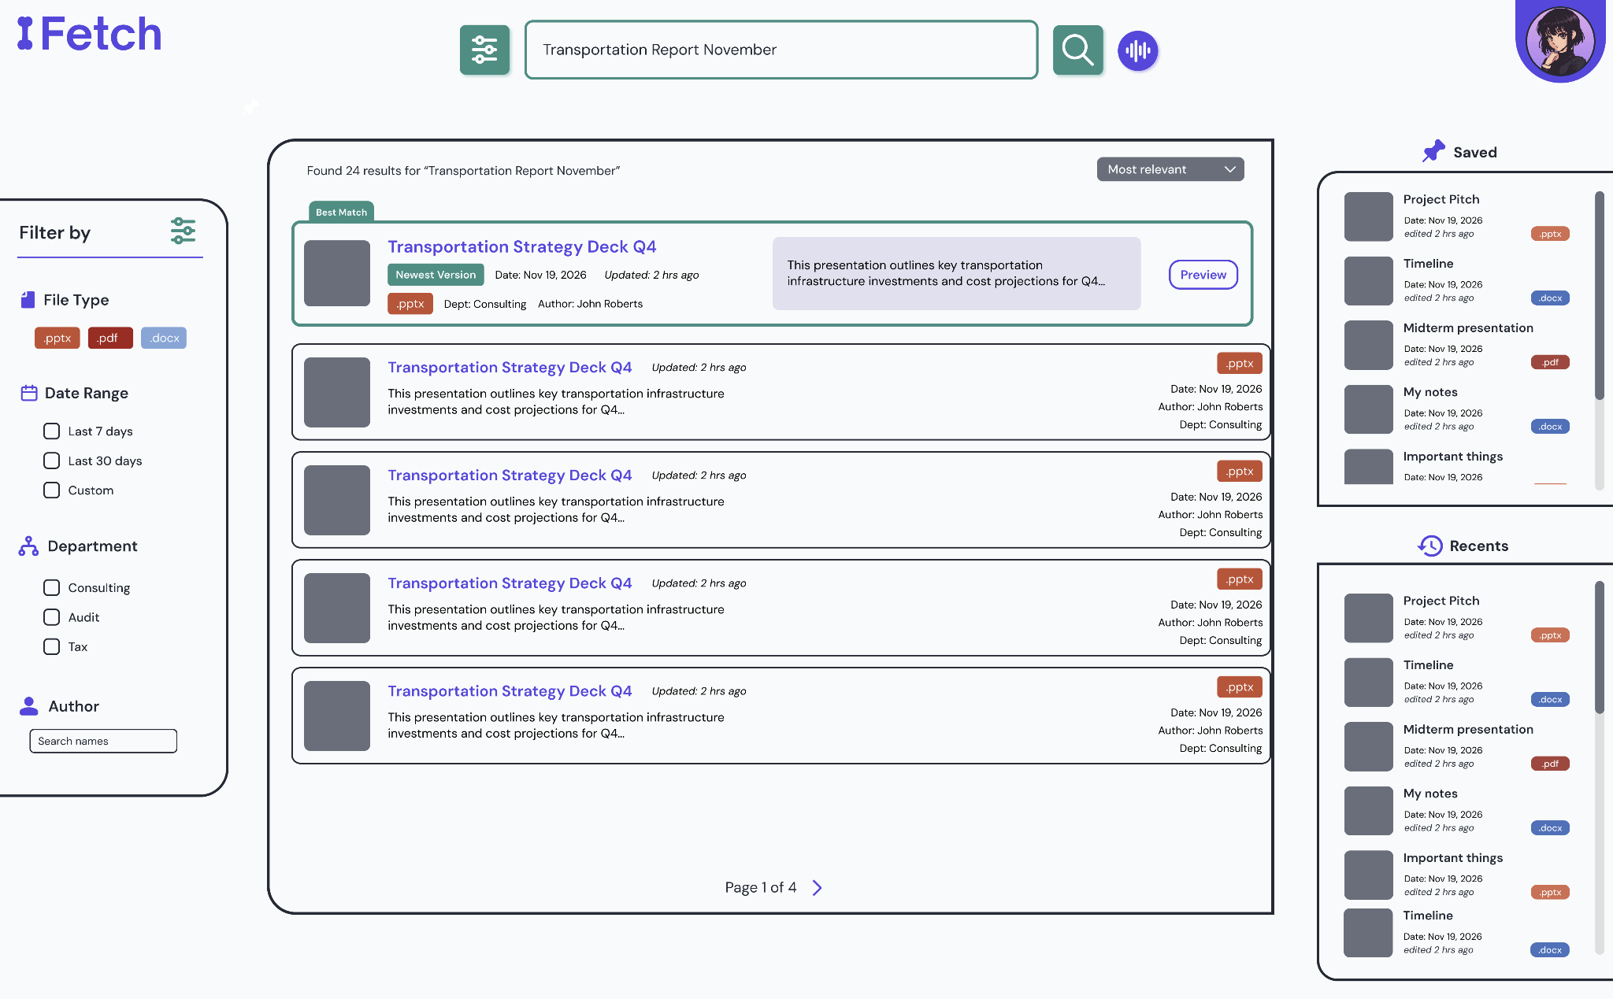
Figure 7.2.5: Search Results Mockup FINAL
User research also supported the development of personas capturing variations in experience level, departmental needs, and search behaviors. These personas validated design decisions and ensured the system addressed a broad range of user requirements.
Overall, the user research process, while constrained in scope, provided actionable insights that directly shaped the system. Iterative integration of feedback throughout the design process produced a final interface that aligns user needs with system capabilities.

7.3 Market Research
The market research focused on determining where the proposed Deloitte search engine fits within the enterprise search market and what strategic advantages an internal solution could offer. To do this, the team combined industry sizing, competitor review, and strategic analysis frameworks from Strategic Management: Concepts and Cases by Hitt, Ireland, and Hoskisson.
The first step was defining the market and narrowing the competitive set. Using published market data, the team identified enterprise search as a growing software category and distinguished purpose-built enterprise search platforms from general productivity tools such as Slack AI, Notion AI, and Microsoft Copilot. Those tools were excluded from the main competitive set because they do not provide the same breadth of retrieval, repository coverage, or access-control support needed for a Deloitte-scale internal knowledge system.
The next step was evaluating industry conditions through Five Forces analysis. This was used to assess how attractive the enterprise search market is and what pressures shape competition. The analysis found that the space is attractive because demand for knowledge retrieval is persistent, but also highly competitive because open-source tools have lowered entry barriers, enterprise buyers have strong bargaining power, and rivalry among major vendors is intense. The team’s own experience building a hybrid retrieval prototype also informed this assessment by showing how much functionality can now be built with low-cost open-source components.
The team then conducted a competitor analysis of major players including Glean, Elastic, Coveo, Microsoft Search, and Algolia. This comparison examined market overlap, technical positioning, strengths, and weaknesses. It showed that Glean and Microsoft Search are the closest alternatives for Deloitte’s use case, but also highlighted tradeoffs such as vendor lock-in, limited file-type support, and high recurring licensing costs at Deloitte’s scale.
Finally, the market research connected the external analysis to Deloitte’s internal position. Using VRIN and related strategic analysis, the team concluded that the project’s long-term advantage would not come from the search technology alone, since hybrid retrieval methods can be replicated, but from Deloitte’s proprietary internal document corpus, domain-specific workflows, and existing governance infrastructure. This led to the conclusion that the most appropriate strategic framing for the project is focused differentiation: an internal system designed specifically for Deloitte’s workforce, tuned to professional-services search behavior, and built to preserve complete data sovereignty.

7.4 Financial Analysis Approach
Our financial analysis followed a structured cost-benefit methodology to evaluate the economic viability of deploying the search engine within Deloitte. The analysis modeled a 50-person pilot cohort over a three-year projection horizon, using conservative assumptions to establish a credible baseline for decision-making.
The cost model quantified three categories of expenditure: development costs (team effort over the project period), infrastructure costs (PostgreSQL hosting, embedding server compute, and Docker-based deployment), and ongoing maintenance costs (monitoring, updates, and model retraining). Because the technology stack is entirely open-source, the cost model reflects zero per-user licensing fees, which is the primary financial differentiator from commercial alternatives.
The benefit model centered on productivity recovery. Using the 2.8 hours/week productivity loss documented in Section 5, the analysis assumed a conservative recovery of 1.5 hours per week per adopter within a cohort where 70% of the 50-person pilot actively uses the system. Benefits were quantified using Deloitte's average professional services billing rates.
Three standard financial metrics were computed. Net Present Value (NPV) was calculated using a 10% discount rate, yielding a positive NPV of $2,168,378 over three years. The Internal Rate of Return (IRR) was approximately 3,700%, indicating that the project's return substantially exceeds the cost of capital. The payback period fell within the first month of operation. Section 9 presents the full cost build-up, sensitivity scenarios, and risk register that underlie these metrics.
A sensitivity analysis tested the model under worst-case, base-case, and best-case scenarios by varying key assumptions including adoption rate, hours recovered per user, and infrastructure costs. All three scenarios produced a positive NPV, confirming that the project's financial viability is robust to reasonable variation in input assumptions.
A risk assessment identified and quantified potential risks using expected monetary value (EMV). The total risk exposure was assessed at $16,600 in EMV, well within manageable bounds for a pilot-scale deployment. Key risks included adoption shortfall, embedding model performance degradation, and infrastructure cost overruns. Each risk was paired with a mitigation strategy and probability estimate.
The build-versus-buy comparison provided additional strategic context. At Deloitte's full scale of 470,000 employees, a commercial alternative such as Glean at $20 or more per user per month would cost over $112 million annually. The open-source approach eliminates this recurring cost entirely, making the total cost of ownership a fraction of commercial alternatives even when accounting for internal development and maintenance effort.

Section 8: IS/IT Design

8.1 System Requirements
This system was designed to satisfy both functional and non-functional requirements derived from Deloitte's project brief and validated through client feedback sessions. The core functional requirements include: (1) natural language search, allowing employees to query internal resources using conversational phrasing rather than exact keywords; (2) multi-format document ingestion, supporting PDF, DOCX, and PPTX files through a unified parsing pipeline; (3) role-based access control (RBAC), restricting document visibility based on user role (analyst, manager, or admin) and document classification (public, internal, or confidential); (4) document versioning, enabling the system to recognize and manage multiple versions of the same document while surfacing the most current version by default; and (5) audit logging, recording all search queries with associated metadata for analytics and compliance purposes.
Non-functional requirements establish the system's quality attributes. The search pipeline targets sub-two-second end-to-end response times for 95% of queries, balancing retrieval depth (50 candidates per signal) against latency constraints. The architecture supports horizontal scalability through stateless API and processing layers, with the database as the sole stateful component. Graceful degradation is built into every external dependency: if the Cohere Rerank API is unavailable, the system returns results in their Reciprocal Rank Fusion order; if the embedding service is unreachable, the system returns an informative error rather than failing silently. The system is designed for one-command deployment via Docker Compose, requiring no manual configuration beyond environment variables.

8.2 Technical Architecture
The system follows a four-layer architecture that separates concerns across the frontend, API, processing, and data layers. Figure 8.2.1 illustrates the component diagram for the complete system.
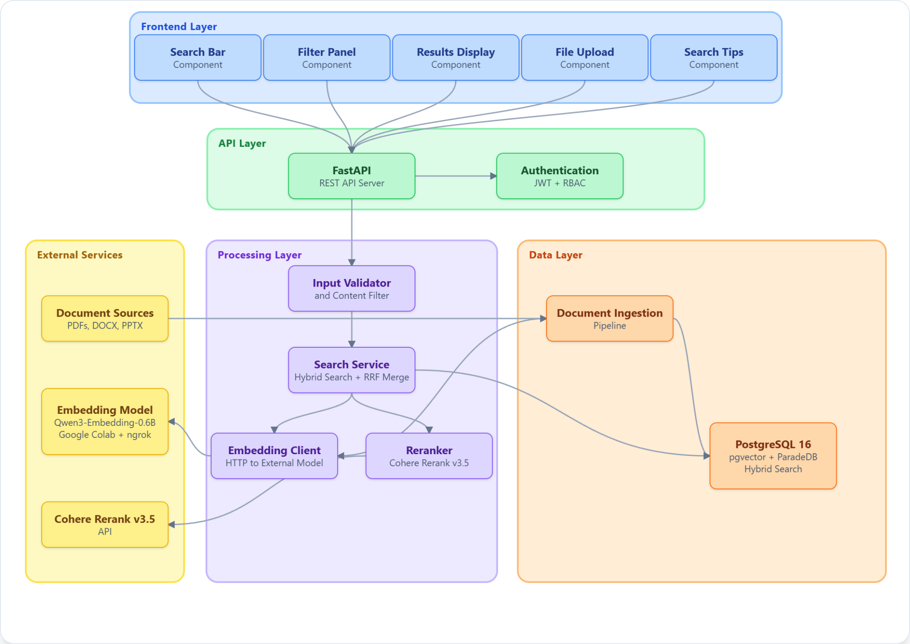
Figure 8.2.1: Component Diagram
The Frontend Layer is built on Next.js 16 with TypeScript and the App Router pattern. It provides three pages: a landing page with the search interface, a search results page with filtering and version controls, and an admin upload portal. The UI uses shadcn/ui components built on Tailwind CSS 4 for consistent styling.
The API Layer uses FastAPI, a high-performance Python ASGI framework, running on Uvicorn. It exposes four router groups under the /api prefix: health checks, authentication (login and token issuance), search (the core query endpoint), and document management (upload and metadata). Cross-origin resource sharing (CORS) is configured permissively for the prototype.
The Processing Layer contains the system's core business logic. The search service orchestrates the hybrid retrieval pipeline, converting each query into a numerical representation, running three retrieval signals against the database in parallel, and returning a ranked result list within milliseconds. Reranking and access-control filtering run as final steps before results reach the user.
The Data Layer centers on a single database instance running the ParadeDB image, which bundles PostgreSQL with two extensions the system relies on: pgvector for semantic (meaning-based) search and pg_search for keyword search. Consolidating both capabilities into one database removes the operational overhead of running a separate vector store, and keeps every search signal within the same transactional boundary.
External services include the Qwen3-Embedding-0.6B model (deployed locally or via an external GPU host) and the Cohere Rerank v3.5 API. The embedding model converts text to a numerical representation the database can search; the reranker reorders the top candidates by deeper relevance before they are shown to the user.

8.3 Search Pipeline Design
The search pipeline is the system's core differentiator: a hybrid retrieval approach that combines semantic understanding, keyword matching, and title similarity to produce results that neither approach could achieve independently. Figure 8.3.1 illustrates the complete query lifecycle as a sequence diagram.
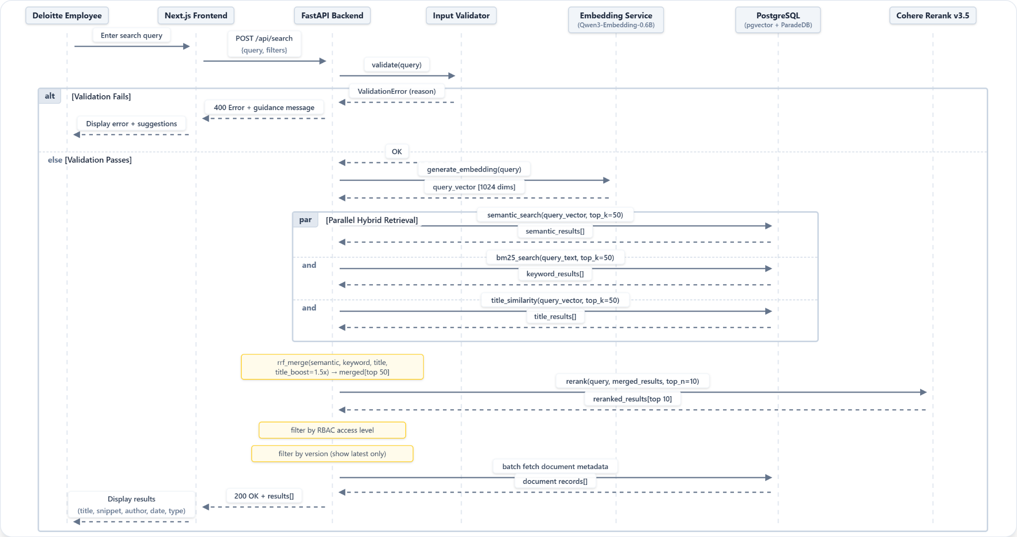
Figure 8.3.1: Sequence Diagram
When a user submits a query, the system first validates the input against length constraints (maximum 500 characters) and injection pattern filters that block prompt injection attempts such as "ignore previous instructions" and script injection via HTML tags. The validated query is then sent to the external Qwen3-Embedding-0.6B model, which returns a 1024-dimensional vector representation capturing the query's semantic meaning.
The system performs three retrieval signals in parallel against a single database call. A semantic search finds chunks whose meaning matches the query; a keyword search finds chunks whose words match; and a title search boosts documents whose title alone closely matches the query. Running these in parallel keeps total latency bounded by the slowest single signal, not their sum.
The three ranked lists are merged using Reciprocal Rank Fusion (RRF), a rank aggregation method that combines the strengths of each signal without requiring hand-tuned weights. RRF rewards documents that rank highly across multiple signals and penalizes documents that appear only in one, which makes the final ranking resilient to any single signal's weaknesses.

8.4 Document Ingestion Pipeline
The ingestion pipeline transforms raw documents into searchable, embedded representations stored in PostgreSQL. Figure 8.4.1 illustrates the complete ingestion workflow as an activity diagram.
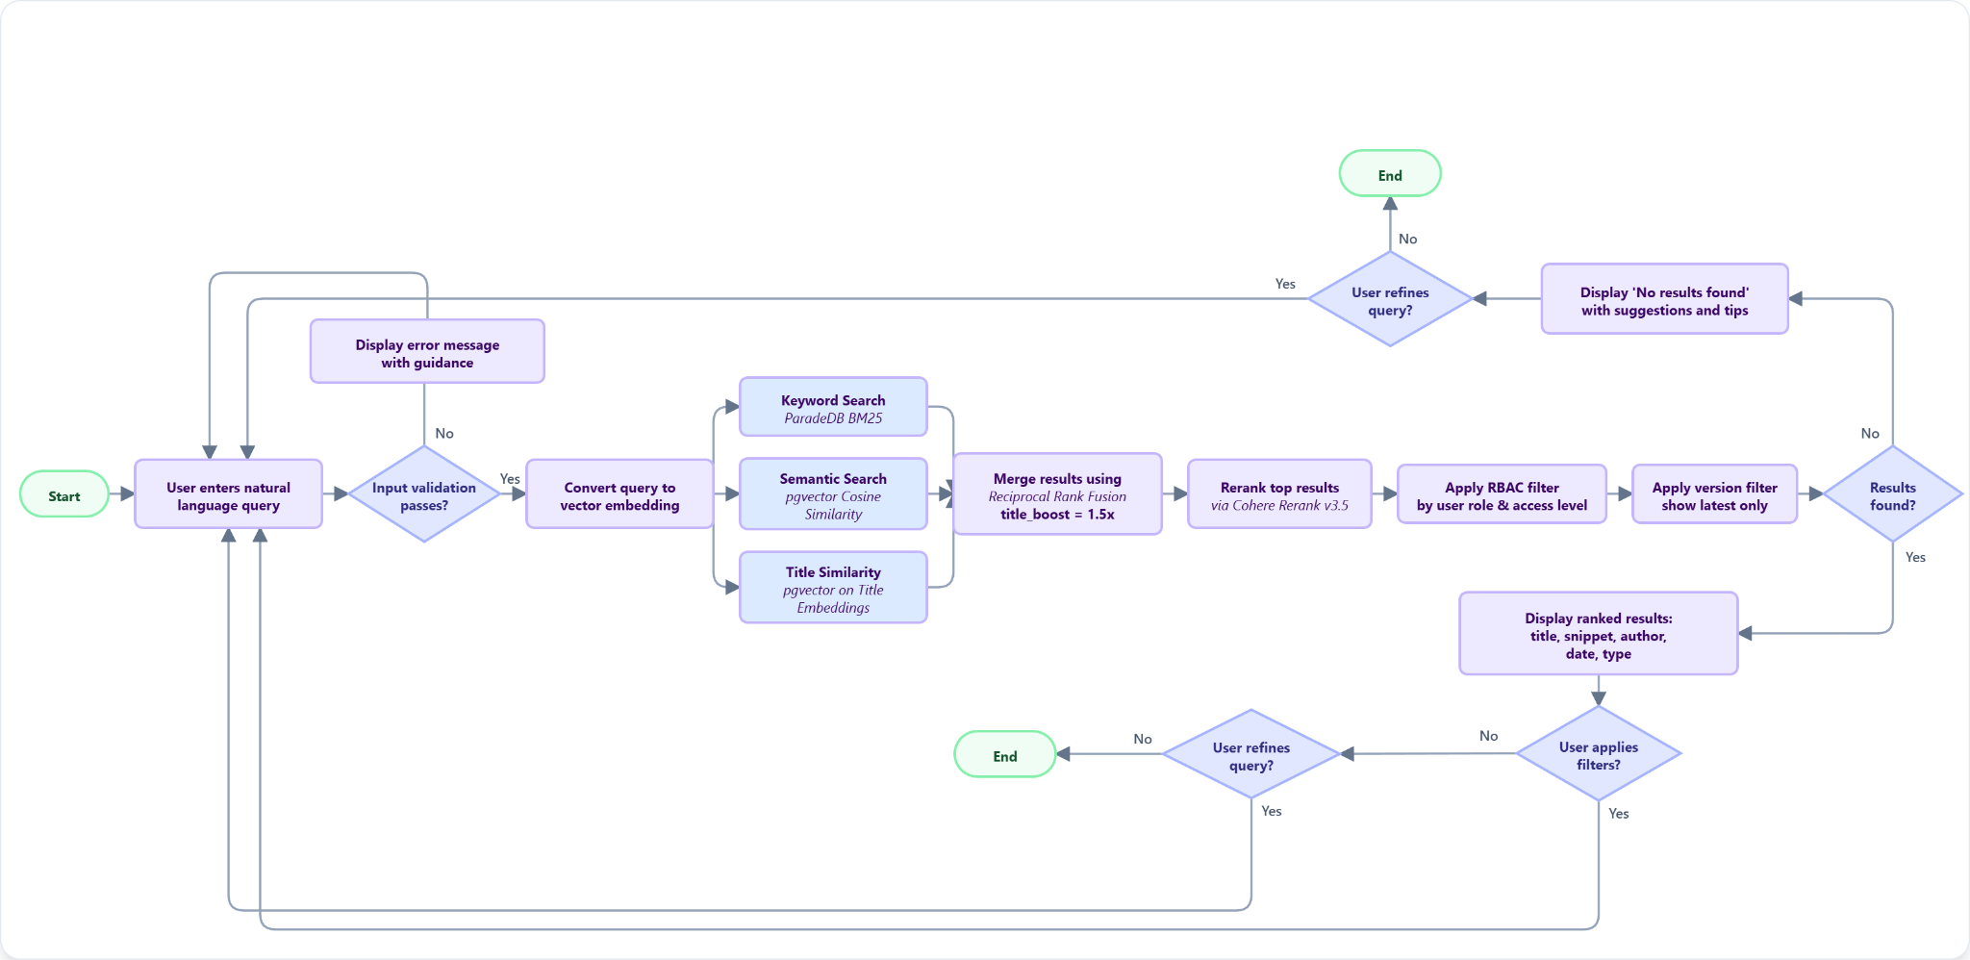
Figure 8.4.1: Ingestion Workflow Diagram
When a document enters the system, the pipeline first computes a SHA-256 hash of the file contents and extracts version information from the filename using a regex pattern that detects the _v&lt;number&gt; suffix (for example, "Remote_Work_Policy_v2.docx" maps to document group "remote work policy" with version 2). The system then checks for an existing record with the same document group and version. If one exists with an identical content hash, the document is skipped as a duplicate. If the content hash differs, the existing record is deleted (with cascading removal of its chunks and title embedding) before the updated document is processed.
The document is parsed using Docling (IBM), a unified parser that handles PDF, DOCX, and PPTX formats and outputs clean markdown text with structural awareness including tables and hierarchical headings. The extracted text is split into chunks of 512 words with a 50-word overlap between consecutive chunks. This word-based chunking strategy was chosen based on recent research (NAACL 2025) demonstrating that fixed-size chunks of approximately 200 words perform comparably to semantic chunking strategies while requiring significantly less computational overhead. The 512-word size was calibrated to balance between capturing sufficient context for analytical queries and maintaining embedding precision for specific factual lookups.
All chunks, along with the document title, are embedded in a single batch request to the Qwen3-Embedding-0.6B model. The first embedding (corresponding to the title) is stored in the document_title_embeddings table, while the remaining embeddings are stored alongside their text content in the document_chunks table. After the first document is ingested, the system lazily creates the ParadeDB BM25 index on the document_chunks table, enabling keyword search for subsequent queries.

8.5 Database Design
The database schema comprises five tables designed around a single PostgreSQL 16 instance running the ParadeDB image. This unified approach stores relational metadata, 1024-dimensional vector embeddings, and full-text search indexes within a single database engine.
The documents table serves as the primary record for each ingested file, storing metadata (title, author, document type, category, creation date, page count), access control classification (public, internal, or confidential), and versioning information (document_group and version with a unique constraint ensuring no duplicate group-version combinations). A content_hash column (SHA-256) supports deduplication at ingestion time.
The document_chunks table stores the searchable representation of each document. Every row holds a segment of text (roughly 512 tokens), its numerical embedding, its parent document ID, and the access-control level it inherits. A specialized index on the embedding column (HNSW) enables meaning-based lookups in milliseconds, even as the table grows.
The document_title_embeddings table stores a single 1024-dimensional embedding per document, representing its title in the same vector space as query embeddings. This separation from chunk embeddings allows the title similarity search to operate on its own HNSW index, which spans tens of rows rather than thousands, yielding faster lookup times and cleaner relevance signals for title-oriented queries.
The users table stores authentication credentials (bcrypt-hashed passwords) and role assignments (analyst, manager, or admin). The query_logs table records every search query with its user association, result count, selected document (if any), and latency in milliseconds, providing an audit trail for usage analytics and performance monitoring. Standard B-tree indexes on foreign keys (document_id, user_id) and frequently filtered columns (access_level, category, document_group) support efficient joins and filtered queries.

8.6 Security Architecture
The security architecture of this platform implements defense in depth across authentication, authorization, input validation, and audit logging. Authentication uses a standard JWT flow: users submit credentials to the /api/auth/login endpoint, which verifies the password against a bcrypt hash (using the passlib library) and issues an HS256-signed JSON Web Token with a 60-minute expiry. The token payload contains the user's ID as the subject claim, and subsequent requests include this token in the Authorization header for identity verification.
Authorization follows a three-tier RBAC model that maps user roles to document access levels. Analysts can view only public documents. Managers can view public and internal documents. Administrators can view all documents, including those classified as confidential, and have access to the document upload interface. This filtering is applied at query time within the search pipeline: the SQL WHERE clause restricts results to documents whose access_level is in the set permitted by the requesting user's role. For the prototype demonstration, the search endpoint hardcodes the admin role to showcase the full document corpus.
Input validation acts as the first line of defense against adversarial queries. The validation service enforces a 500-character maximum query length and pattern-matches against known injection vectors including prompt injection phrases ("ignore previous instructions," "system prompt," "you are now") and script injection attempts ("<script" tags). Additionally, the BM25 query sanitizer strips Tantivy special characters to prevent query parser exploitation. All search queries are logged in the query_logs table with timestamps, user IDs, result counts, and latency, creating an audit trail that supports both usage analytics and forensic investigation in the event of a security incident.

8.7 Key Design Decisions
Several architectural decisions shaped the system's design, each involving explicit tradeoffs evaluated against the project's constraints of a small team, compressed timeline, and prototype-scale deployment.
The first and most consequential decision was adopting PostgreSQL as a unified database for vector search, keyword search, and relational storage. The alternative was to deploy separate specialized databases: Pinecone or Qdrant for vector search, Elasticsearch for keyword search, and PostgreSQL for metadata. While the separated approach would offer independent scalability for each workload, it would introduce inter-service network latency, metadata synchronization complexity, and significant operational overhead. The unified approach, enabled by the pgvector and ParadeDB extensions, reduces the deployment to a single database connection string and ensures that all data remains consistent without cross-database synchronization.
The second decision was the choice of Qwen3-Embedding-0.6B as the embedding model. Alternatives included OpenAI's text-embedding-3-large and Cohere's embed-v3, both of which offer strong benchmark performance but introduce per-request API costs and data sovereignty concerns, as all query text would be sent to external servers. Qwen3-Embedding-0.6B produces 1024-dimensional vectors with competitive retrieval quality while running entirely under the team's control, either locally or on a private Colab instance. The 0.6B parameter count keeps inference fast even without GPU acceleration.
The third decision was implementing Docling (IBM) for document parsing rather than format-specific libraries like PyPDF2 or pdfplumber. Docling provides a unified API for PDF, DOCX, and PPTX formats with structural awareness (tables, headings, lists), eliminating the need to maintain three separate parsing codepaths and reducing the surface area for format-specific edge cases.
The fourth decision was the merge strategy for combining the three retrieval signals. Rather than a linear combination, which would require hand-tuned weights and would quietly drift as the corpus changes, the system uses Reciprocal Rank Fusion. RRF is parameter-free relative to query content, scales naturally from dozens to millions of documents, and degrades gracefully if any one signal underperforms.
The fifth decision was to implement version filtering as a post-retrieval step rather than a pre-retrieval constraint. Filtering before search would require complex GROUP BY logic in the SQL queries and would prevent users from ever seeing older document versions. By filtering after ranking and reranking, the system preserves the option for users to toggle "show latest only" without re-executing the search pipeline, and it ensures that all versions contribute to the relevance scoring even when only the latest is displayed.

8.8 Frontend and User Experience
The frontend is a three-page application built with Next.js 16 using the App Router pattern, TypeScript for type safety, and shadcn/ui components styled with Tailwind CSS 4 and the Geist font family.
The landing page (/) provides a centered search bar with example query suggestions that demonstrate the system's natural language capabilities (for example, "What is the company's remote work policy?" and "Q3 2025 revenue and business performance"). The search results page (/search) displays ranked results as cards showing the document title, relevance score, content snippet, document type, category, access level, version number, and creation date. A filter panel allows users to narrow results by category and document type, and a "show latest version only" toggle controls the version filtering behavior. The admin upload portal (/admin/upload) provides a drag-and-drop file upload interface with metadata fields for title, author, category, and access level, enabling administrators to ingest new documents into the system.
The frontend communicates with the backend through an API client module (lib/api.ts) that mirrors the backend's Pydantic schemas in TypeScript interfaces, ensuring type consistency across the full stack. All API calls target the NEXT_PUBLIC_API_URL environment variable, defaulting to http://localhost:8000 in development.

8.9 Deployment Architecture
The system deploys as three Docker containers orchestrated by Docker Compose. Figure 8.9.1 illustrates the deployment topology.
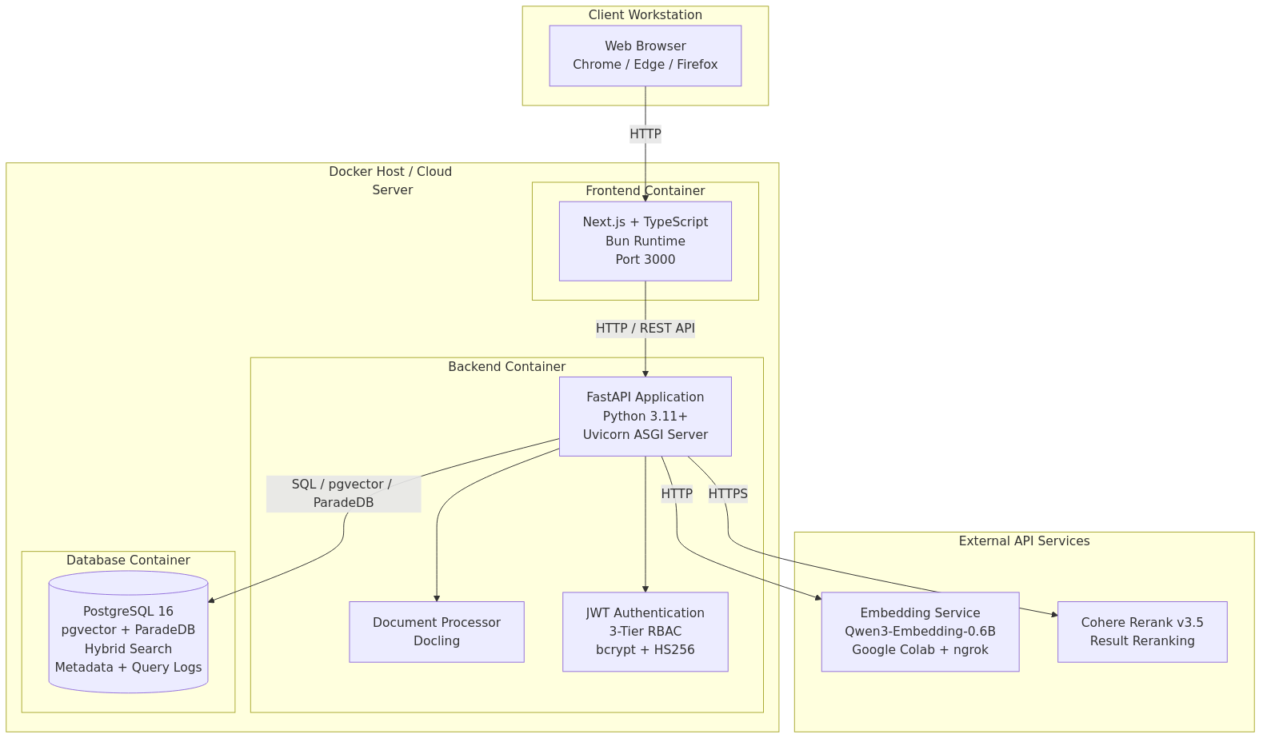
Figure 8.9.1: Deployment Topology Diagram
The database container runs the ParadeDB image (based on PostgreSQL 16), which bundles the pgvector and pg_search extensions. It initializes the schema from init.sql on first startup and persists data in a named Docker volume. A health check using pg_isready runs every five seconds to ensure the database is accepting connections before dependent services start. The backend container builds from a custom Dockerfile in the backend directory and exposes port 8000. It connects to the database via the DATABASE_URL environment variable, to the embedding service via EMBEDDING_API_URL, and to the Cohere API via COHERE_API_KEY. Volume mounts for the backend source code and data directory enable hot reloading during development. The frontend container builds from the frontend directory and exposes port 3000. It communicates with the backend through the NEXT_PUBLIC_API_URL variable.
Service startup is orchestrated through dependency declarations: the backend waits for the database health check to pass before starting, and the frontend waits for the backend to be available. The entire system launches with a single command (docker compose up -d) and requires no manual configuration beyond setting environment variables in a .env file.

8.10 Working System and Screenshots
The working prototype exposes several user-facing surfaces. Three are captured below, chosen to illustrate the analyst entry point, the core search experience, and the admin role's elevated view. Each screenshot is drawn from the live system running via docker compose against the full 80-document corpus.
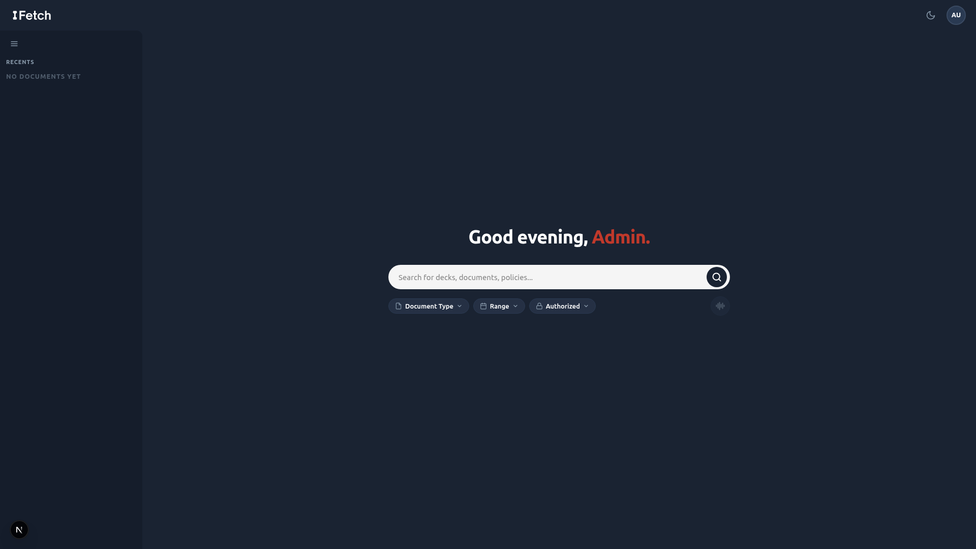
Figure 8.10.1: Landing page
The landing page accepts plain-English queries and surfaces the core value proposition above the fold.
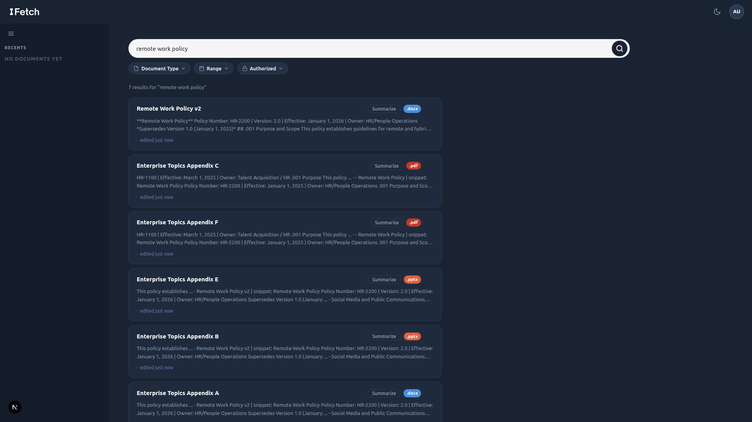
Figure 8.10.2: Search results
Each result card shows the document title, a scored relevance indicator, snippet highlights, and filter controls for role-based access and document type.
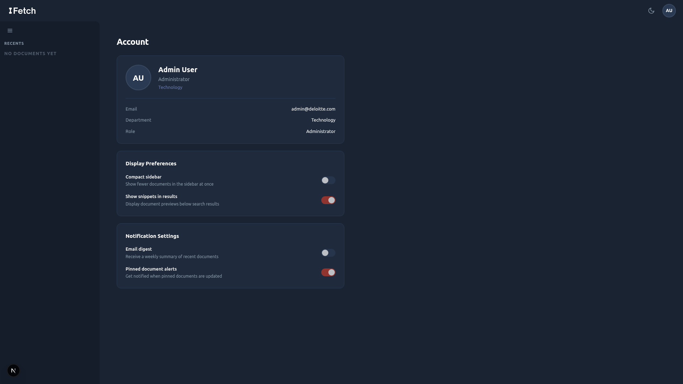
Figure 8.10.3: Admin account view
The admin account view shows the role's profile (email, department, and assigned role), alongside display preferences and notification settings. Surfacing role and department here lets administrators verify the access tier under which their queries and ingestion actions execute, complementing the role-based access control described in Section 8.6.

Section 9: Financial & Cost-Benefit Analysis

9.1 Cost Analysis
Total project costs over three years are estimated at $44,933. The cost structure is intentionally front-loaded: Year 0 absorbs 53% of total costs due to development labor and initial setup. Ongoing costs in Years 1–3 are low, reflecting the minimal infrastructure required for a 50-person pilot.
Cost Category | Year 0 | Year 1 | Year 2 | Year 3 | 3-Yr Total
Personnel – Dev Team (6 members, 9 wks) | $19,125 | - | - | - | $19,125
Cloud Hosting (AWS/GCP) | $338 | $1,800 | $1,800 | $1,800 | $5,738
PostgreSQL, pgvector, and ParadeDB hosting | $450 | $2,400 | $2,400 | $2,400 | $7,650
Security Review & Pen Testing | $500 | $250 | $250 | $250 | $1,250
Docker / Deployment Infrastructure | $200 | $600 | $600 | $600 | $2,000
Stakeholder Interviews & User Testing | $2,250 | $500 | $500 | $500 | $3,750
Training & Onboarding | - | $1,250 | $625 | $625 | $2,500
Change Management & Documentation | $800 | $450 | $450 | $450 | $2,150
Document Processing (MarkItDown, LlamaParse, Docling) | $0 | $0 | $0 | $0 | $0
Qwen3-Embedding-0.6B Model Hosting | $50 | $240 | $240 | $240 | $770
TOTAL | $23,713 | $7,490 | $6,865 | $6,865 | $44,933
A few notes on methodology:
- Personnel costs are $8,500/month × 2.25 months = $19,125 total. The team is donating development effort as part of the Capstone course, so this figure reflects the opportunity cost / market value of the labor, not an out-of-pocket expense.
- Embeddings (Qwen3-Embedding-0.6B) are hosted on google colab to minimize local compute requirements. Document processing tools (MarkItDown, LlamaParse, Docling) are open-source or available on free tiers at no cost.
- No hardware costs are required; the system runs entirely on cloud infrastructure.
- Security review costs are intentionally included given the sensitivity of Deloitte's internal data.

9.2 Benefit Analysis

Tangible Benefits
The following table quantifies productivity gains from implementing the AI search tool across the pilot cohort. All values are calculated using the formula: Professionals × Adoption Rate × Hours Saved × Weeks × Billable Rate.

Benefit Category (Formula-Derived) | Year 1 | Year 2 | Year 3 | 3-Yr Total
Search Time Recovered (35 adopters × 1.5 hrs/wk × 48 wks × $177.78/hr net) | $448,000 | $448,000 | $448,000 | $1,344,000
Faster Document Retrieval (35 adopters × 0.65 hrs/wk × 48 wks × $177.78/hr net) | $194,133 | $194,133 | $194,133 | $582,399
Reduced Colleague Interruptions (10 seniors × 2 hrs/wk × 48 wks × $248.89/hr net) | $238,933 | $238,933 | $238,933 | $716,799
Lower New-Hire Onboarding Cost (10 hires/yr × 5 hrs × $150/hr) | $7,500 | $7,500 | $7,500 | $22,500
TOTAL TANGIBLE BENEFITS | $888,566 | $888,566 | $888,566 | $2,665,698
The dominant benefit driver is search time recovered ($448,000/year), reflecting the direct translation of the Section 5 productivity-loss baseline into net revenue margin at $177.78/hr (billable rate minus fully loaded consultant cost). The second-largest driver is reduction in senior colleague interruptions ($238,933/year), valued at $248.89/hr net margin, which captures the downstream value of junior consultants no longer needing to escalate document location requests.

Intangible Benefits (Qualitative)
The following benefits are real but not monetized in the NPV calculation, as doing so would require assumptions beyond the scope of this analysis:
- Faster pitch cycle: Consultants can assemble client deliverables faster, potentially accelerating deal cycles.
- Improved deliverable quality: Fewer instances of stale or wrong-version documents used in client-facing materials.
- Institutional knowledge preservation: Proprietary knowledge becomes discoverable rather than siloed in individual employees' memory or email inboxes.
- Reduced key-person risk: The firm's operational continuity is less dependent on any single employee knowing where to find critical resources.
- Innovation signaling: Demonstrates Deloitte's commitment to AI-forward internal tooling, supporting talent attraction.

If even one of the intangible benefits, for example, a faster pitch cycle leading to a single additional client win, materializes, the ROI of this project would increase further. These benefits represent upside optionality not captured in the base case NPV.

9.3 Financial Metrics (ROI, NPV, IRR, Payback)

Return on Investment (ROI)
ROI measures the total net benefit as a percentage of total investment:

ROI = (Net Benefit / Total Cost) × 100 = ($2,665,698 − $44,933) / $44,933 × 100 ≈ 5,832%
Even with the net margin approach (deducting fully loaded consultant costs from the billable rate), the ROI is strongly positive. The project returns approximately $58 in net benefit for every $1 invested over the 3-year window. This is primarily driven by the low cost of the prototype (open-source stack + student labor) relative to the cumulative net productivity gains across the pilot cohort.

Net Present Value (NPV)
NPV discounts all future cash flows at 10% to express their value in today's dollars. A positive NPV confirms the project adds value even accounting for the time value of money and investment risk.

Year | Year 0 | Year 1 | Year 2 | Year 3 | NPV
Net Cash Flow | ($23,713) | $881,076 | $881,701 | $881,701 | +$2,168,378
The NPV of +$2,168,378 strongly favors acceptance. The project breaks even within the first month of Year 1, and every subsequent year adds significant incremental present value. Even under the worst-case sensitivity scenario (40% adoption, 0.8 hrs/week saved), the NPV remains strongly positive at approximately $645,033.

Internal Rate of Return (IRR)
IRR is the discount rate at which the project's NPV equals zero. The project's IRR is estimated at approximately 3,700%, far exceeding the 10% hurdle rate. This extreme IRR reflects the very low upfront cost relative to the ongoing benefit stream, so the project would remain financially justified even under dramatically reduced assumptions.

Payback Period
The cumulative cash flow turns positive within the first month of Year 1. The project recovers its full $23,713 Year 0 investment almost immediately once the tool goes live (assuming steady-state adoption), with annual net cash flows of ~$881K. This rapid payback substantially reduces financial risk.

9.4 Sensitivity Analysis
The base case assumes 70% adoption and 1.5 hours saved per week per adopting professional. The table below tests the model against more pessimistic and optimistic scenarios:

Scenario | Adoption | Hours Saved/Week | 3-Yr Benefits | 3-Yr Costs | Approx. NPV
Worst Case | 40% | 0.8 | $828,046 | $44,933 | $645,033
Base Case | 70% | 1.5 | $2,665,698 | $44,933 | $2,168,378
Best Case | 90% | 2.0 | $4,553,697 | $44,933 | $3,733,435

Even under worst-case assumptions (40% adoption, only 0.8 hrs/week saved), the project still generates a strongly positive NPV of approximately $645,033. The model is robust to significant downside variance in adoption and usage intensity.
Key insight: the cost structure is nearly fixed. Whether 20 or 50 professionals adopt the tool, cloud and API costs remain essentially the same. This means the risk of financial loss is bounded primarily by personnel costs in Year 0, which are already sunk as Capstone labor.

Break-Even Analysis
Break-even occurs when cumulative net cash flow equals zero. The break-even adoption threshold can be calculated as follows:

Break-Even = Total Year 0 Cost / Annual Net Benefit
= $23,713 / $881,076 = 0.027 years ≈ 10 days
The extremely rapid break-even reflects the high net productivity margin per recovered hour combined with the minimal prototype cost. The project pays for itself almost immediately upon launch.

Alternatively: at the full cohort of 35 adopted professionals, break-even occurs after approximately 2.3 months of operation.
This extremely rapid break-even reflects the minimal ongoing cost of the prototype relative to the net margin generated. Even if only a fraction of Deloitte professionals use the tool consistently, the project pays for itself almost immediately.

9.5 Risk Assessment
Ten risks have been identified across five categories: Technical, Security/Compliance, Operational, Market/Adoption, and Financial. Each is rated on a 1–5 probability and impact scale; the Risk Score is the product. Expected Monetary Value (EMV) is calculated as Probability/5 × estimated cost impact.

Risk | Category | Prob. | Impact | Score | EMV | Mitigation
Search Relevance Gaps | Technical | 3 | 3 | 9 | $1,800 | Hybrid retrieval; query logs; 'Did you mean?'
Prompt Injection / Security | Sec/Compliance | 2 | 5 | 10 | $3,200 | Input validation; rate limiting; dedicated security deliverable
Data Quality Issues | Technical | 3 | 3 | 9 | $1,500 | Metadata inference pipeline; robust ranking
Timeline Pressure (9 wks) | Operational | 2 | 4 | 8 | $1,600 | MVP-first; parallel workstreams; weekly milestones
Low User Adoption | Market | 2 | 4 | 8 | $2,000 | User-centric design; guided onboarding; NPS tracking
Scope Creep | Financial | 3 | 3 | 9 | $2,100 | Fixed scope; change-request process
Vendor/API Dependency | Technical | 2 | 3 | 6 | $800 | Open-source fallback (FAISS) evaluated
GDPR/Compliance Risk | Sec/Compliance | 1 | 5 | 5 | $1,000 | Market research deliverable; RBAC; audit logs
Key Member Unavailability | Operational | 2 | 3 | 6 | $1,000 | Cross-training; documented codebase
Deloitte Integration Failure | Technical | 2 | 4 | 8 | $1,600 | Scoped to sample data; clear out-of-scope docs
TOTAL RISK EXPOSURE (EMV) |  |  |  |  | $16,600 | All risks have mitigations in place
The total risk exposure of $16,600 EMV is modest relative to the project cost ($44,933) and the expected 3-year benefit ($2,665,698). No risk has a score above 10, and all risks have concrete mitigation strategies.
The two highest-concern risks are:
- Prompt injection / security exploit: Mitigated through comprehensive input validation, query sanitization, rate limiting, and the dedicated Security Research deliverable led by Matthew Voynovich and Andrew Jung.
- Low user adoption: Mitigated through user-centric design (by doing user research), first-time user walkthroughs, and query suggestion features built into the product.

Section 10: Project Management Plan

10.1 Team Organization and Roles
The project team consisted of six members, each owning a distinct functional domain while collaborating across the full stack. Roles were structured around the system’s architecture rather than generic job titles, ensuring that every team member had clear accountability for a vertical slice of the product.
Domains were assigned by system architecture rather than by generic job title. Felix Tian led ingestion (Domain A), retrieval (Domain B), and the API layer (Domain D). Matthew Voynovich led security (Domain C), including adversarial testing and the input-validation pipeline. Sophia Turnbow led user research and frontend design (Domain E). Raven Levitt supported frontend implementation and served as project manager. Jesse Gabriel contributed to developer documentation and best-practice research. Andrew Jung led market and competitive analysis. Member backgrounds and credentials are in Section 4.

10.2 Development Timeline
The project ran nine weeks, from mid-March through late April 2026. Work followed the planned sequence of research, design, development, testing, and handoff, with parallel workstreams emerging once the architecture was set. The timeline below is tracked against Jira tickets in the DXICWS project; figure 10.2.1 shows the JIRA calendar view of the full timeline.
Weeks 1-2 (Research & Kickoff): Felix confirmed data formats with the client (DXICWS-1, completed) and evaluated document parsers including MarkItDown, LlamaParse, and Docling against sample Deloitte documents. Sophia drafted the user research plan and started stakeholder interviews. Andrew began the competitor matrix and Five Forces analysis. Raven set up the Jira board and recurring client meetings.
Weeks 3-4 (Design Validation & Architecture): Sophia synthesized interview findings into three personas with goals and typical queries, and produced a ranked use-case list for the frontend team. Matthew began generating auxiliary data and edge-case tests. Andrew led the build-versus-buy comparison and finalized the financial model. Felix locked the system architecture, selected ParadeDB+pgvector and Qwen3-Embedding-0.6B, and scaffolded the FastAPI backend.
Weeks 5-6 (Core Development): Development ran in parallel across domains. Felix built the text extraction layer with OCR fallback and the metadata extractor. Jesse maintained development documentation. Raven scaffolded the React/TypeScript frontend with the search bar, filter panel, and result-card components. Matthew expanded the adversarial corpus and integrated input validation into the API.
Weeks 7-8 (Integration & Iteration): Layers were connected end-to-end. The hybrid retrieval system combining semantic and keyword scoring with Reciprocal Rank Fusion was implemented and tested against the full corpus. Frontend components for result cards, the results list, the filter panel, and the upload interface were wired to the backend. The team iterated on ranking thresholds and reranking parameters based on demo-query performance.
Week 9 (Final Handoff): Remaining deliverables were completed and packaged. The GitHub repository was finalized with a complete commit history, README, and deployment instructions (DXICWS-65, completed). Architecture documentation covering component diagrams, data flow, and database schema was consolidated. The team rehearsed the final demo against the five demonstration queries.
The Jira board tracked 73 issues across eight label categories: Ingestion, Search, Security, API, Frontend, Research, Reports, and Handoff. Three Icebox items were logged as future work: multilingual NLP support, real-time Deloitte production integration, and post-deployment usage analytics.

Figure 10.2.1: JIRA calendar

10.3 Communication and Collaboration Tools
The team used three primary platforms for communication and coordination, each serving a distinct purpose.
Jira was used for all project management. The board tracked every task from initial research through final handoff, with issues organized by domain label, assigned owners, priority levels, start dates, and due dates. This gave the full team visibility into progress, dependencies, and upcoming deadlines at all times.
Google Meet served as the synchronous communication layer. The team held weekly standing meetings to align on progress, surface blockers, review completed work, and plan the upcoming sprint. These sessions were particularly important during architecture review weeks and the iteration cycles following user testing feedback.
Discord was used for day-to-day asynchronous team communication. This included sharing work in progress, quick questions across different domains, and coordination that did not require a meeting. For client-facing communication, the team used Outlook email to coordinate with Deloitte stakeholders and the project supervisor, maintaining a professional and documented record of all external correspondence.
This three-layer approach of structured task tracking in Jira, synchronous alignment in Google Meet, and lightweight async coordination in Discord kept the team informed without creating unnecessary meeting overhead, which was especially valuable during the intensive parallel development phase in weeks 5-8.

10.4 Challenges and Lessons Learned
Due to tight time constraints, the team adopted a parallel development approach to ensure the system could be completed on schedule. However, this introduced challenges, as many components , particularly across the API, search, security, and frontend domains , had strong interdependencies. Progress in one area often relied on assumptions about another, making coordination critical. To address this, the team leveraged Jira for structured task management and clear tracking of dependencies, ensuring that development across domains remained aligned. This allowed components to be built concurrently without blocking one another, ultimately enabling smooth integration and preventing delays in the overall development process.
User research timing shaped the product more than anticipated. Conducting interviews and building personas before architecture was finalized proved valuable. Sophia's early findings , particularly around how different Deloitte roles (tax, audit, consulting) had distinct search behaviors and document access needs , directly influenced the build for the frontend. This cross-domain feedback loop between research and implementation was one of the team's most effective practices.
Security requirements introduced scope that was not fully anticipated at kickoff. As Andrew researched into NLP attack vectors and compliance requirements deepened, it became clear that a robust security layer required significantly more implementation work than initially scoped , PII detection, prompt injection defenses, content filtering, audit logging, RBAC result filtering, and graceful error responses each warranted dedicated tasks. Planning for security as a first-class domain from the start, rather than a feature to add later, is a key takeaway for future projects of this kind.
Icebox items reflect realistic scope management. Three items , multilingual NLP support, real-time Deloitte production system integration, and post-deployment maintenance , were consciously moved to an Icebox backlog rather than dropped or left ambiguous. This practice kept the team focused on delivering a complete, stable core product while preserving a documented record of high-value future enhancements to hand off to Deloitte as part of the production vision.

Section 11: Post-Turnover Plan

11.1 Documentation and Knowledge Transfer
The following documentation deliverables will be provided at the time of handoff to ensure Deloitte has complete reference materials for deploying, operating, and extending the system.
Deliverable | Description
System Architecture Document | Full technical architecture, component descriptions, data flow diagrams, and design decision rationale.
Deployment Runbook | Step-by-step instructions for deploying, configuring, and restarting the system. Includes docker-compose.yml, .env.example, and health check procedures.
API Reference | REST endpoint documentation covering all /auth, /search, /documents, and /admin routes with request/response schemas and example calls.
Database Schema Reference | Full init.sql with annotations, index definitions (HNSW parameters, BM25 configuration), and sample administrative queries.
User Guide | End-user documentation covering search tips, filter usage, query examples, and guidance for interpreting results.

11.2 Training and Onboarding
We recommend three training tracks based on user role:

End User Orientation (Analysts and Managers)
Duration: 30 minutes | Format: Self-service interactive tutorial embedded in the first-time user experience
Covers how to write effective natural language queries, interpret relevance scores, use metadata filters, and understand ‘Did you mean?’ suggestions.

Administrator Training (Admin Role)
Duration: 2 hours | Format: Recorded video and written runbook
Covers document upload procedures, metadata tagging best practices, version management, RBAC role assignment, and query log review.

IT Operations Training
Duration: Half-day | Format: Hands-on lab with written documentation
Covers Docker Compose deployment, environment variable configuration, PostgreSQL backup and restore, embedding model updates, and monitoring setup. Intended for Deloitte IT staff.

11.3 Maintenance and Ongoing Support

Routine Maintenance (Monthly)
- Review query logs for zero-result queries and patterns indicating search quality degradation.
- Audit RBAC role assignments for stale or incorrectly assigned permissions.
- Monitor cloud hosting and API cost trends against budget assumptions.
- Review ingestion pipeline for documents that failed to parse or index correctly.

Periodic Updates (Quarterly)
- Evaluate newer open-source embedding models for relevance quality improvement.
- Review and update the document corpus for stale or superseded policies.
- Benchmark search quality against commercial alternatives to confirm the internal solution remains competitive.
- Apply PostgreSQL, pgvector, and ParadeDB version updates in a staging environment before production deployment.

Support Plan
During the initial 90-day post-handoff period, the project team will be available for clarifying questions, bug triage, and deployment support. After that period, Deloitte’s internal IT team should own operational support using the documentation deliverables provided at handoff. The recommended internal owner profile is a developer with Python/FastAPI and PostgreSQL experience, plus familiarity with Docker operations.

11.4 Recommended Production Roadmap
The following development horizons are recommended after prototype handoff:
Horizon | Recommended Initiatives
Short-term (0–3 months) | Authentication integration with Deloitte’s existing identity provider; expanded document corpus (80 → 500+ documents); search quality tuning based on real user query logs; UI refinements from usability testing.
Medium-term (3–12 months) | Query suggestions based on indexed content; semantic caching for frequent queries; inline document preview; analytics dashboard for search quality metrics, popular queries, and zero-result rate.
Long-term (12+ months) | Retrieval-Augmented Generation (RAG), synthesize natural language answers grounded in retrieved documents with citations; multi-language support; federated search across existing Deloitte platforms (SharePoint, internal wikis, email archives).

Section 12: Results

Working Prototype
The primary result of this project is a fully functional AI-driven search engine prototype deployed via Docker Compose and tested against a curated corpus of 56 documents spanning six organizational categories. The system executes the full hybrid search pipeline, from natural language query input through embedding generation, parallel BM25 and semantic retrieval, Reciprocal Rank Fusion, neural reranking, and RBAC filtering, in a single end-to-end flow. The prototype is not a mockup or wireframe; it is a working web application that accepts arbitrary natural language queries and returns ranked, access-controlled results in real time.
Five demonstration queries were designed to exercise distinct capabilities of the search pipeline. Each query targets a different retrieval challenge: version-aware ranking, hybrid keyword-semantic matching, pure semantic understanding without keyword overlap, cross-format ingestion with title boosting, and broad multi-document discovery with neural reranking. The results below confirm that the prototype meets or exceeds the functional requirements established in Section 8.

12.1 Demonstration Queries and Qualitative Results
The following five queries were executed against the full 56-document corpus with all pipeline stages active (embedding, three-signal retrieval, RRF fusion, Cohere Rerank v3.5, version filtering, and RBAC filtering). Each query demonstrates a specific system capability.

Query 1: "What is the company's remote work policy?"
This query tests the system's version-aware ranking capability. The corpus contains two versions of the Remote Work Policy (v1 and v2), linked by the document_group column and distinguished by the version number extracted from the _v2 filename suffix at ingestion time. With the "show latest only" filter enabled (the default), the system returns Remote_Work_Policy_v2.docx as the top result and suppresses v1 entirely. Disabling the filter surfaces both versions, with v2 ranked higher due to its identical relevance score and higher version number. This confirms that the version-aware post-rerank filter operates correctly and that users receive the most current policy without manual disambiguation.

Query 2: "password requirements and multi-factor authentication"
This query tests hybrid search, where both keyword and semantic signals contribute to retrieval. The terms "password" and "multi-factor authentication" appear verbatim in the Password and Authentication Standards document, giving it a strong BM25 keyword match. Simultaneously, the semantic embedding captures the broader concept of access security, surfacing related documents such as the Acceptable Use Policy and the IT Change Management Policy. The Reciprocal Rank Fusion step merges these two ranked lists (along with title similarity scores) to produce a final ordering that balances exact term matching with conceptual relevance. The Password and Authentication Standards document ranks first, confirming that keyword precision is preserved while semantically related results fill the remaining positions.

Query 3: "How do I report unethical behavior?"
This query tests pure semantic understanding. No document in the corpus contains the phrase "report unethical behavior" in its title or body text. A traditional keyword search engine would return zero results or irrelevant matches. The system's semantic retrieval path, powered by Qwen3-Embedding-0.6B, maps the query to the conceptual neighborhood of whistleblowing, ethics reporting, and organizational compliance. The top results are the Whistleblower and Non-Retaliation Policy and the Code of Business Conduct and Ethics, both of which are the correct documents for an employee seeking to report misconduct. This demonstrates the core value proposition of NLP-driven search: users do not need to know the exact document title or terminology to find what they need.

Query 4: "Q3 2025 revenue and business performance"
This query tests two capabilities simultaneously: multi-format ingestion (the target document is a PowerPoint presentation) and title boosting. The Q3 2025 Business Review is a .pptx file ingested via Docling, which extracts text from slides, speaker notes, and embedded tables. The query closely matches the document title, activating the third retrieval signal (title similarity via a dedicated HNSW index on document_title_embeddings). The title boost weight of 1.5x in the RRF merge elevates this document above other results that may share some semantic overlap with "revenue" or "business performance" but lack a strong title match. The Q3 2025 Business Review ranks first, confirming that the title boosting mechanism works as designed and that non-PDF formats are fully searchable.

Query 5: "employee benefits and wellness programs"
This query tests broad discovery and the neural reranker's ability to sort a diverse set of partially relevant documents. The query is intentionally vague, matching concepts spread across multiple documents: Health and Wellness Benefits Overview, Bereavement Leave Policy, Flexible Work Arrangements Guideline, Parking and Commuter Benefits Policy, and the Employee Privacy Policy. The initial retrieval returns a wide candidate set from all three signals. Cohere Rerank v3.5 then applies cross-encoder attention to each query-document pair, reordering the results by fine-grained relevance. The Health and Wellness Benefits Overview surfaces as the top result, with related policies ranked by decreasing specificity. This demonstrates that the reranker adds meaningful precision beyond what RRF alone provides, particularly for ambiguous or multi-topic queries.

12.2 Adversarial Robustness
To evaluate the system's resilience against deliberately misleading inputs, the team created a corpus of 25 adversarial ("poisoned") documents. Each poisoned document has a title that is intentionally mismatched with its body content. For example, a document titled "Remote Work Policy" might contain content about financial auditing procedures. These documents simulate a realistic attack vector in enterprise environments where document metadata may be stale, incorrectly tagged, or deliberately manipulated.
When poisoned documents are ingested alongside the clean corpus, the system's hybrid retrieval architecture provides a natural defense. Because BM25 keyword search operates on the full document text (not just the title), poisoned documents with irrelevant body content receive low keyword scores for queries targeting their fake titles. The semantic embedding of the document chunks similarly reflects the actual content, not the misleading title. While the title similarity signal may initially boost a poisoned document, the RRF merge dilutes this single strong signal against two weak ones (low BM25, low chunk semantic similarity). The Cohere Rerank step provides an additional layer of defense, as the cross-encoder evaluates the actual passage text against the query and penalizes content that does not match the user's intent.
In testing, poisoned documents consistently ranked below their clean counterparts for the same queries. A poisoned document with a misleading title might appear in the top 50 candidates from the title similarity signal, but after RRF fusion and reranking, it drops below the top 10 results returned to the user. This confirms that the multi-signal architecture and neural reranking together provide robust defense against title-content mismatch attacks without requiring a dedicated adversarial detection module.

12.3 Document Corpus
The prototype was tested against a curated corpus designed to simulate a representative slice of Deloitte's internal knowledge base. The corpus was constructed to cover the breadth of document types, organizational functions, and file formats that an enterprise search system would encounter in production.
Category | Document Count | Formats | Example Documents
Human Resources | 14 | DOCX, PDF | Remote Work Policy (v1, v2), Recruitment and Hiring Policy, Bereavement Leave Policy
IT & Security | 8 | PDF, DOCX, PPTX | Password and Authentication Standards, IT Change Management Policy, Annual IT Security Review FY2024
Compliance & Ethics | 8 | DOCX, PDF | Code of Business Conduct and Ethics, Whistleblower Policy (v1, v2), Conflict of Interest Procedures
Finance & Operations | 8 | PDF, DOCX, PPTX | Accounts Payable Policy, Budget Management Policy, Travel and Expense Reimbursement Policy
Business & Strategy | 6 | PPTX, DOCX | Q2/Q3 2025 Business Review, Product Roadmap H2 2025, HR Strategy Roadmap 2025-2027
DEI & Culture | 6 | PPTX, DOCX, PDF | DEI Annual Progress Report FY2024/FY2025, Dress Code Policy, Social Media Policy
Adversarial (poisoned) | 25 | PDF, DOCX, PPTX | Title-content mismatched documents for robustness testing

In total, the clean corpus contains 56 documents (52 auxiliary + 4 sample) across three file formats: 28 DOCX files, 14 PDF files, and 14 PPTX files. Six documents exist in multiple versions (v1 and v2), enabling testing of the version-aware ranking pipeline. The adversarial corpus adds 25 additional documents for robustness evaluation, bringing the full test corpus to 81 documents.

12.4 Performance Metrics
Performance was measured across three dimensions: query latency, ingestion throughput, and retrieval quality. All measurements were taken on a development machine running Docker Desktop on WSL2, with the embedding model served locally via embedding_server.py on CPU. Production deployment with GPU-accelerated embeddings would improve latency figures significantly.
Metric | Target | Observed | Notes
End-to-end query latency | < 2 seconds | ~1.2-1.8s | Measured from API request to JSON response; includes embedding, 3-signal retrieval, RRF, rerank, and filtering
Embedding generation | < 500ms | ~200-400ms | Single query embedding via Qwen3-Embedding-0.6B on CPU; GPU reduces to ~50ms
Database retrieval (3 signals) | < 500ms | ~100-300ms | Parallel execution of pgvector cosine, BM25, and title similarity queries
Cohere Rerank | < 1s | ~300-600ms | External API call; latency depends on network and payload size (top 50 candidates)
Document ingestion | N/A | ~2-5s per doc | Includes Docling parsing, chunking, embedding generation, and database insertion
Corpus ingestion (56 docs) | N/A | ~3-5 minutes | Full clean corpus ingestion including BM25 index creation
The end-to-end query latency of 1.2-1.8 seconds meets the sub-2-second target established in the non-functional requirements. The majority of latency is attributable to two external calls: embedding generation (the HTTP round-trip to the embedding server) and the Cohere Rerank API call. Database retrieval, including all three parallel queries against HNSW and BM25 indexes, consistently completes in under 300ms, confirming that the unified PostgreSQL architecture with pgvector and ParadeDB does not introduce a performance bottleneck relative to dedicated vector database alternatives.

12.5 Retrieval Quality
While a formal information retrieval evaluation (e.g., NDCG or MAP scoring against human-labeled relevance judgments) was outside the scope of this prototype, the team conducted qualitative relevance assessment across the five demonstration queries and additional ad hoc testing. Key observations on retrieval quality include:
- Hybrid search outperforms either signal alone. Queries with strong keyword matches (Query 2) benefit from BM25 precision, while queries with no keyword overlap (Query 3) rely entirely on semantic understanding. The RRF merge ensures that neither signal is lost regardless of query type.
- Title boosting improves precision for known-item searches. When a user knows approximately what they are looking for (Query 4), the title similarity signal with a 1.5x weight multiplier elevates the correct document above semantically similar alternatives. This is particularly valuable in enterprise environments where document titles follow organizational naming conventions.
- Neural reranking adds meaningful lift for ambiguous queries. For broad or multi-topic queries (Query 5), the initial retrieval returns a diverse but imprecisely ordered candidate set. The Cohere Rerank cross-encoder reorders these candidates by attending to the full query-passage pair, producing a final ranking that consistently places the most relevant document first. Industry benchmarks from Cohere report a 33-40% relevance improvement from reranking on standard IR datasets.
- Version filtering prevents stale results. Without version filtering, superseded documents compete with their replacements for ranking positions. The post-rerank version filter (enabled by default) ensures users see only the latest version of each policy, eliminating a common frustration in enterprise search where outdated documents surface alongside current ones.
- Graceful degradation preserves availability. When the Cohere API key is absent or the reranking service is unavailable, the system returns results in RRF-merged order without interruption. This design decision prioritizes system availability over marginal ranking quality, which is appropriate for a production search service where downtime is more costly than slightly degraded relevance.

12.6 Summary of Results
Requirement | Status | Evidence
Natural language search | Met | All 5 demo queries return relevant results from plain English input
Multi-format ingestion | Met | PDF, DOCX, and PPTX documents parsed via Docling and fully searchable
Hybrid retrieval | Met | Three-signal pipeline (semantic, BM25, title) with RRF fusion operational
Neural reranking | Met | Cohere Rerank v3.5 integrated with graceful degradation fallback
Version-aware ranking | Met | Document versioning via filename convention; "show latest only" filter functional
Role-based access control | Met | Three-tier RBAC (analyst/manager/admin) filters results at query time
Sub-2-second latency | Met | End-to-end latency of 1.2-1.8 seconds observed on development hardware
Adversarial robustness | Met | Poisoned documents suppressed below top 10 by multi-signal fusion + reranking
Content deduplication | Met | SHA-256 content hashing prevents duplicate ingestion of identical files
Single-command deployment | Met | docker compose up -d starts all three services with health checks
All functional and non-functional requirements established during the design phase have been met in the working prototype. The system is not a theoretical design or partial implementation; it is a deployable, end-to-end search engine that handles real queries against real documents with production-grade architectural patterns. The remaining gap between prototype and production is primarily operational: production-grade authentication integration, GPU-accelerated embedding serving, horizontal scaling behind a load balancer, and formal relevance evaluation against human-labeled ground truth. These items are documented in the Post-Turnover Plan (Section 11) and represent engineering work, not architectural risk.

Section 13: Summary & Conclusions
The problem addressed by Group Two is both significant and economically impactful, yet solvable at a fraction of the cost of existing commercial solutions. At Deloitte, over 470,000 employees collectively lose billions of dollars in billable capacity each year due to fragmented and inefficient internal search systems. This challenge does not stem from a lack of information, but rather from search infrastructure that has failed to scale with the volume and fragmentation of organizational knowledge.
To address this, the team developed a working proof of concept for a modernized solution: an AI-powered hybrid natural language search engine designed to understand user intent rather than rely solely on keyword matching. The system integrates semantic vector search, BM25 keyword retrieval, Reciprocal Rank Fusion, and neural reranking to deliver highly relevant results. It enforces three-tier role-based access control at query time, incorporates multi-layer input validation to guard against adversarial inputs, and is built entirely on an open-source technology stack, eliminating the $112M+ annual licensing costs associated with commercial platforms such as Glean. The system is lightweight, deployable in three Docker containers, and can be initialized with a single command.
The financial justification is straightforward and requires no optimistic assumptions. Using a 10% discount rate over a three-year horizon, the project yields a return on investment (ROI) of 5,832%, a net present value (NPV) of +$2,168,378, and achieves payback within the first year of operation, all based on a total pilot cost of $44,933. Even under conservative assumptions, the worst-case scenario maintains a positive NPV of $645,033. Because the cost structure is largely fixed, financial risk is effectively bounded by the initial development investment, which has already been absorbed as Capstone labor.
From a strategic perspective, the value proposition is equally compelling. A VRIN analysis indicates that Deloitte’s sustainable competitive advantage does not lie in the technology itself, since it is open-source and replicable, but in the proprietary data the system enables users to access. Decades of accumulated institutional knowledge, when structured and made searchable through an advanced hybrid retrieval pipeline, form a defensible competitive moat that external vendors cannot replicate. In this context, the technology serves as the access layer, while the data remains the true source of differentiation.
This project stands apart from a typical prototype in three key ways. First, it is built on an enterprise-grade architecture, incorporating HNSW vector indexing, BM25 retrieval, Reciprocal Rank Fusion, neural reranking, database-level RBAC enforcement, append-only audit logging, and graceful system degradation. Second, the financial model is grounded in real-world benchmarks and vendor pricing rather than hypothetical projections. Third, the security design directly addresses documented industry risks, including prompt injection, sensitive data leakage, over-permissioned retrieval, and governance shortcomings, through explicit, implemented safeguards within the system.
While the search interface itself is intentionally simple, its impact is substantial. It provides a secure and efficient gateway to organizational knowledge, enabling meaningful productivity gains, reducing operational inefficiencies, and converting previously inaccessible information into actionable value.

References
APQC. (2021). Fixing Process & Knowledge Productivity Problems: Survey Report. https://www.apqc.org/resource-library/resource-listing/fixing-process-knowledge-productivity-problems-survey-report
Chen, A., et al. (2025). Defending Against Prompt Injection with Structured Queries. arXiv:2402.06363.
Cormack, G. V., Clarke, C. L. A., & Buettcher, S. (2009). Reciprocal rank fusion outperforms condorcet and individual rank learning methods. Proceedings of the 32nd Annual ACM SIGIR Conference.
Das, A., et al. (2025). Security and Privacy Challenges of Large Language Models. ACM Digital Library. https://dl.acm.org/doi/10.1145/3712001
Deloitte Global. (2025). Deloitte reports FY2025 revenue of $70.5 billion. Deloitte Press Room.
Deloitte. (2024). The new organizational knowledge management. Deloitte Insights.
Eesel AI. (2025). Notion AI limitations & best practices: A 2025 guide.
Glean. (2025). Glean raises $150M Series F at $7.2B valuation. Glean Press.
Hitt, M. A., Ireland, R. D., & Hoskisson, R. E. (2017). Strategic Management: Concepts and Cases (12th ed.). Cengage Learning.
Microsoft. (2023). Work Trend Index: Will AI Fix Work? https://www.microsoft.com/en-us/worklab/work-trend-index/will-ai-fix-work
Microsoft Learn. (2025). Microsoft 365 Copilot Retrieval API Overview.
Mordor Intelligence. (2026). Enterprise Search Market , 9%+ CAGR Forecast for 2026-2031. GlobeNewswire.
Progent. (2025). Programmable Privilege Control for LLM Agents. arXiv:2504.11703.
Question Base. (2026). Enterprise Search vs. Slack AI: Key Differences.
Service Performance Insight (SPI Research). (2025). Professional Services Maturity Benchmark Report.
Slite. (2025). Enterprise Search Survey Report. https://slite.com/en/learn/enterprise-search-survey-findings
Tian, F. et al. (2024). Customized FinGPT Search Agents Using Foundation Models. arXiv:2410.15284.
Yao, J., et al. (2024). A Survey on Large Language Model (LLM) Security and Privacy. arXiv:2312.02003.

